Music Quiz
- Name ten instruments in a standard orchestra.

- What is half a crotchet called?

- What are the colours of the keys on a piano?

- Name the following notes…

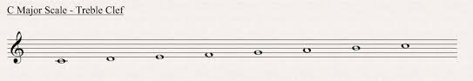

- What is the following instrument?
_ L _ _ _ _ E _
- Name the notes on the stave below.
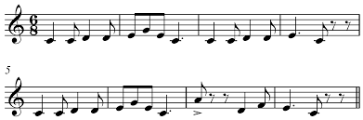
- Approximately how many instruments make up a standard orchestra?

- Freddie Mercury was the lead singer of which pop group?

- Every Good Boy Deserves what?

- Ludwig Van WHO?

