Please watch the video of Mr Howick or Miss Robinson first.

At the Beach
As I stand on the edge of the dunes, I gaze out over the ocean of people crowding the sandy shore, for as far as the eye can see. A rainbow of umbrellas assault my eyes, reflecting light and heat off the bathers that are huddled under their wide reach. Beyond the overcroweded shore, large crashing waves batter the ground, churning up particles of sand and splashing those who stand too close.

Writing Task 1: The beach
LO: We are learning to use the 5 senses to describe a setting.

Write a scene description or a short story using the image and prompts provided. Make sure to use the five senses to help make detailed descriptions in your writing. 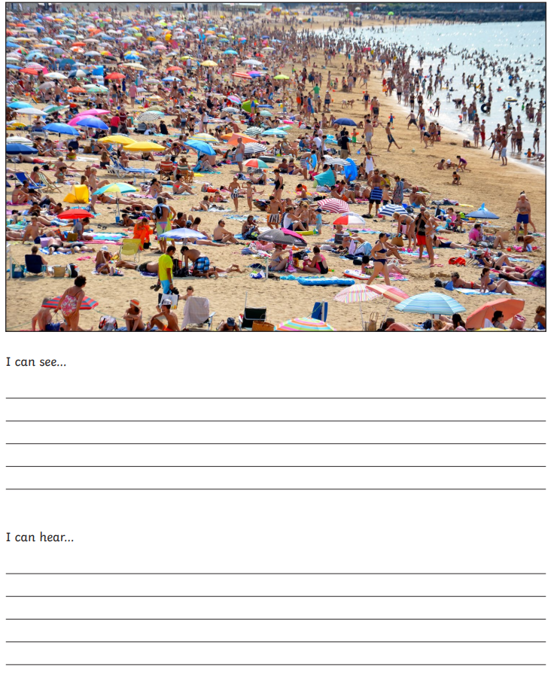

Writing Task 2: Hiking
LO: We are learning to make specific vocabulary choices in our writing
Imagine you have gone on a hike through the forest. Write a scene description or a short story using the image and prompts provided. Make sure to use the five senses to help make detailed descriptions in your writing.
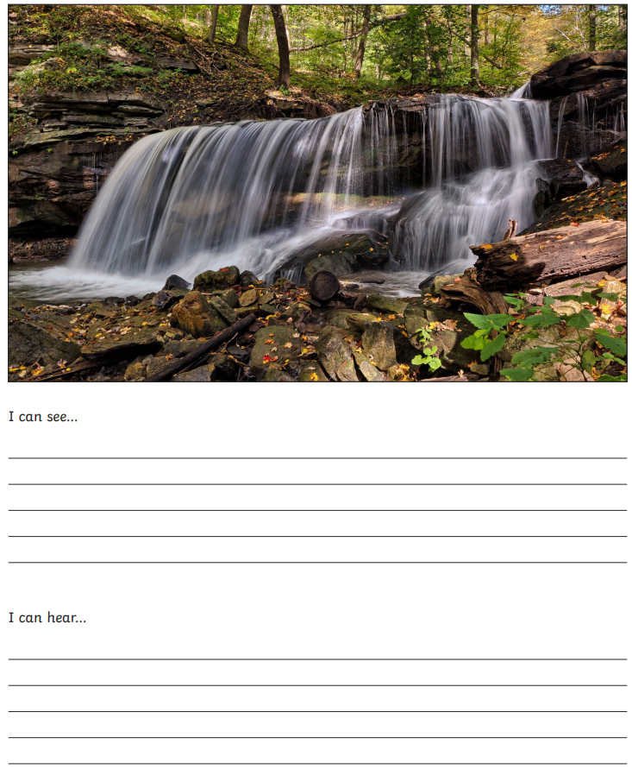

Writing Task 3: Under the sea
LO: We are learning to make specific vocabulary choices in our writing

Imagine you are exploring the ocean and spot an unusual creature. Write a scene description or a short story using the image and prompts provided. Make sure to use the five senses to help make detailed descriptions in your writing.
