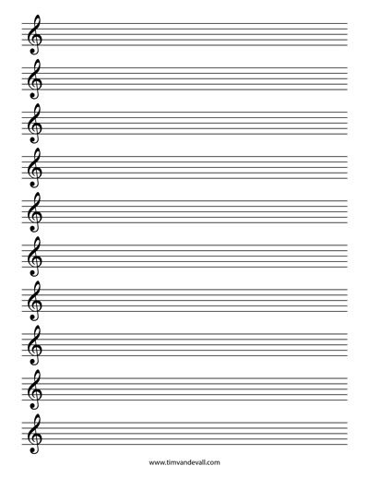

See if you can plot the following notes on the stave… What song is it?
GGAGCB
GGAGDC
GG (high G EC) BA
(High FFECDC)

