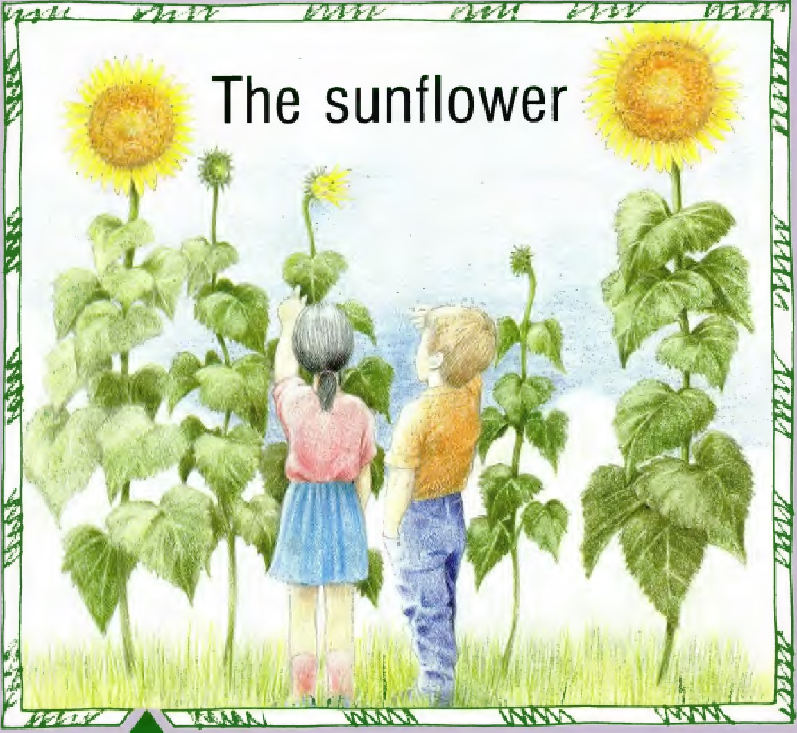
GINN RSCIENCE
Ginn Science Project Team
Sinclair MacLeod Martin Skelton
John Stringer
Consultants and contributors
Trevor Davies
Aileen Duncan Norman Henderson
Kenneth McLeish
Wilma Philip
David Playfoot
Pictures by Carol Phelan

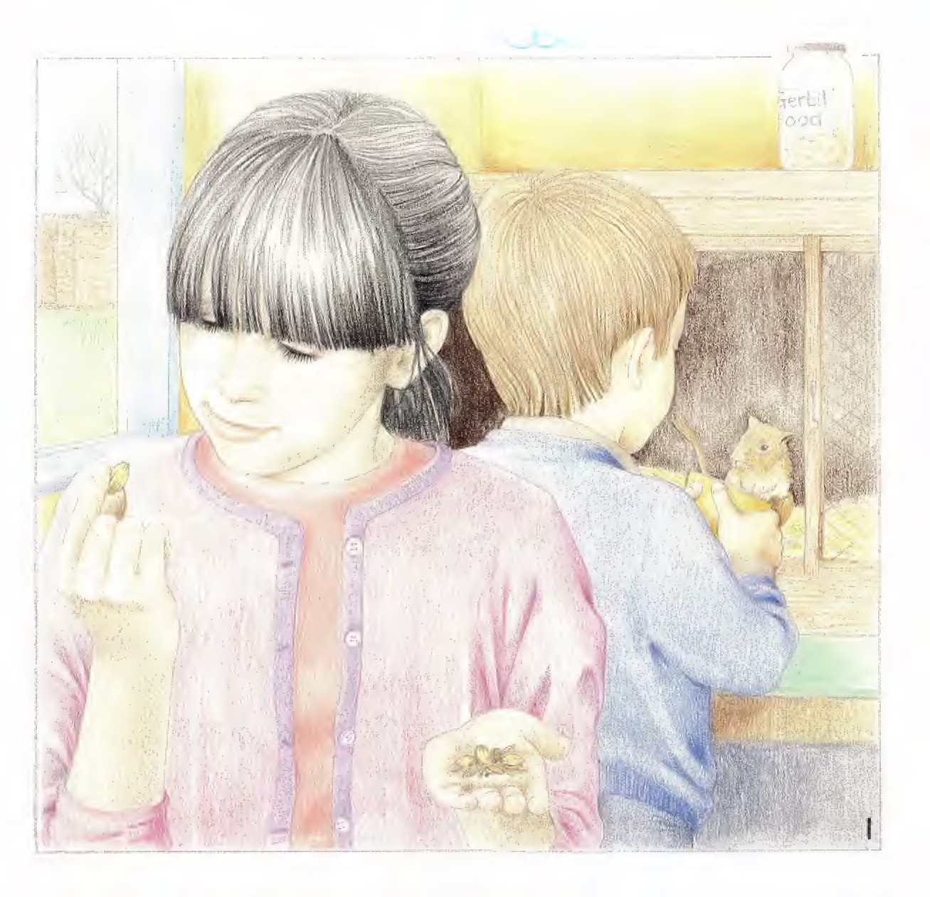
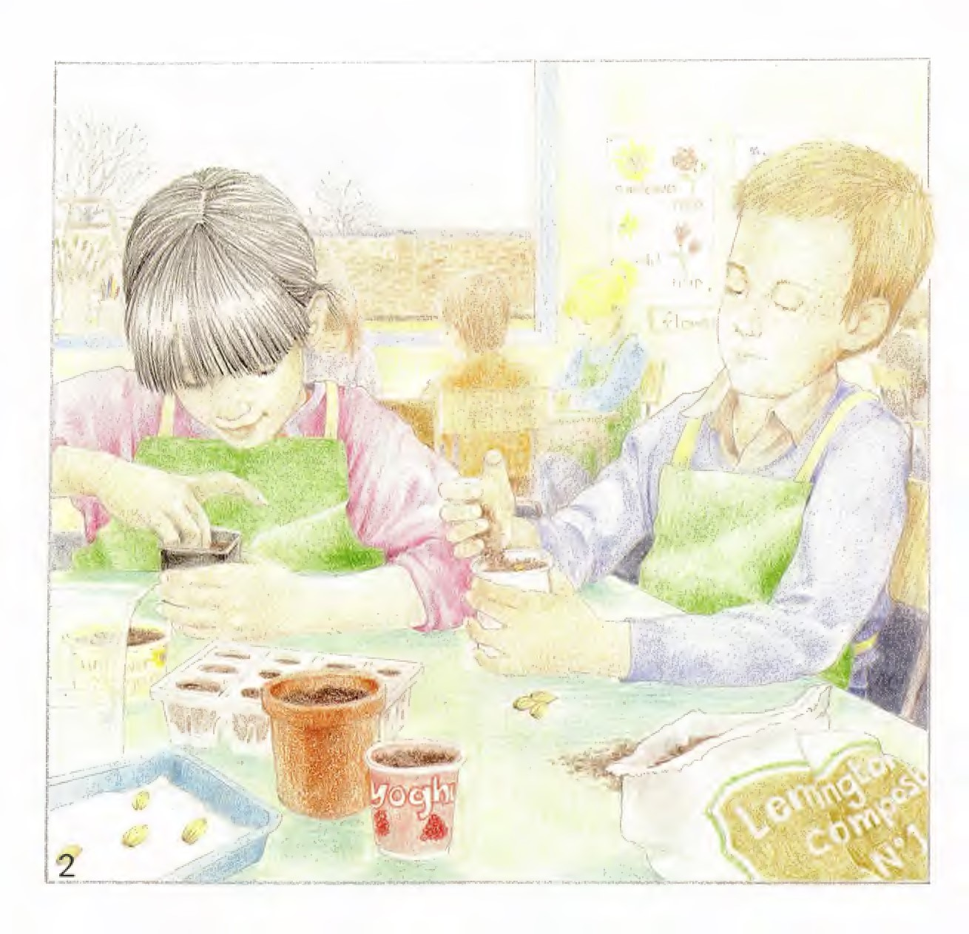
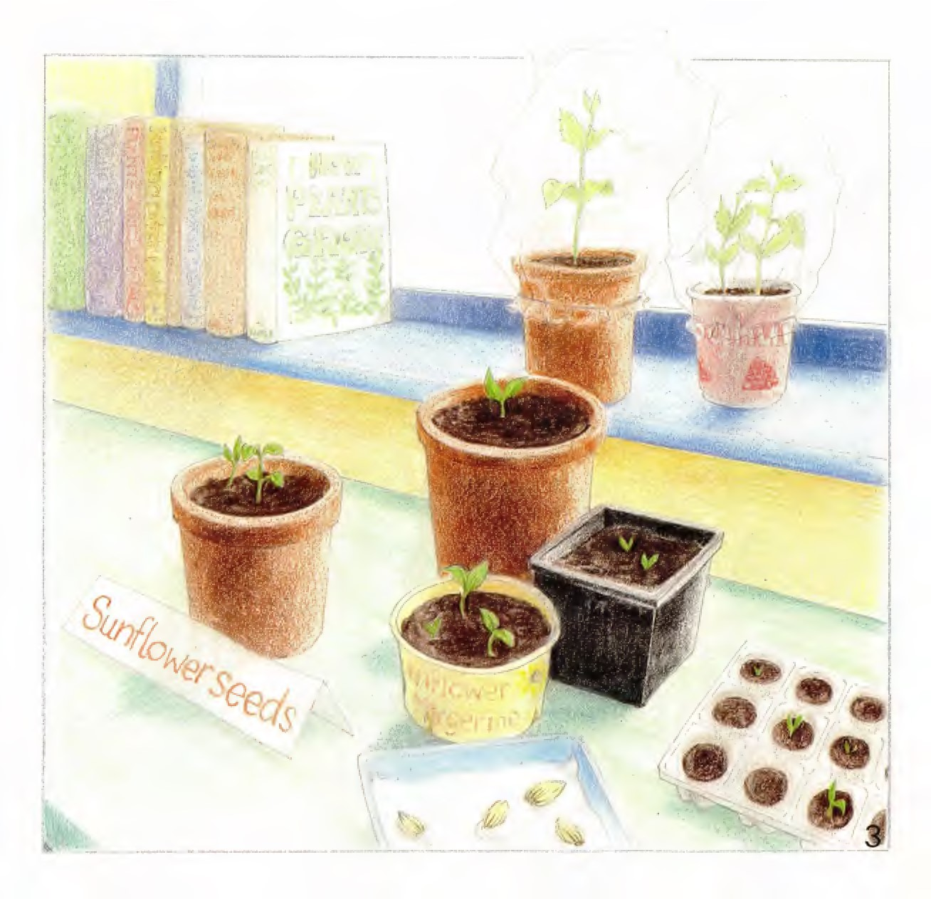
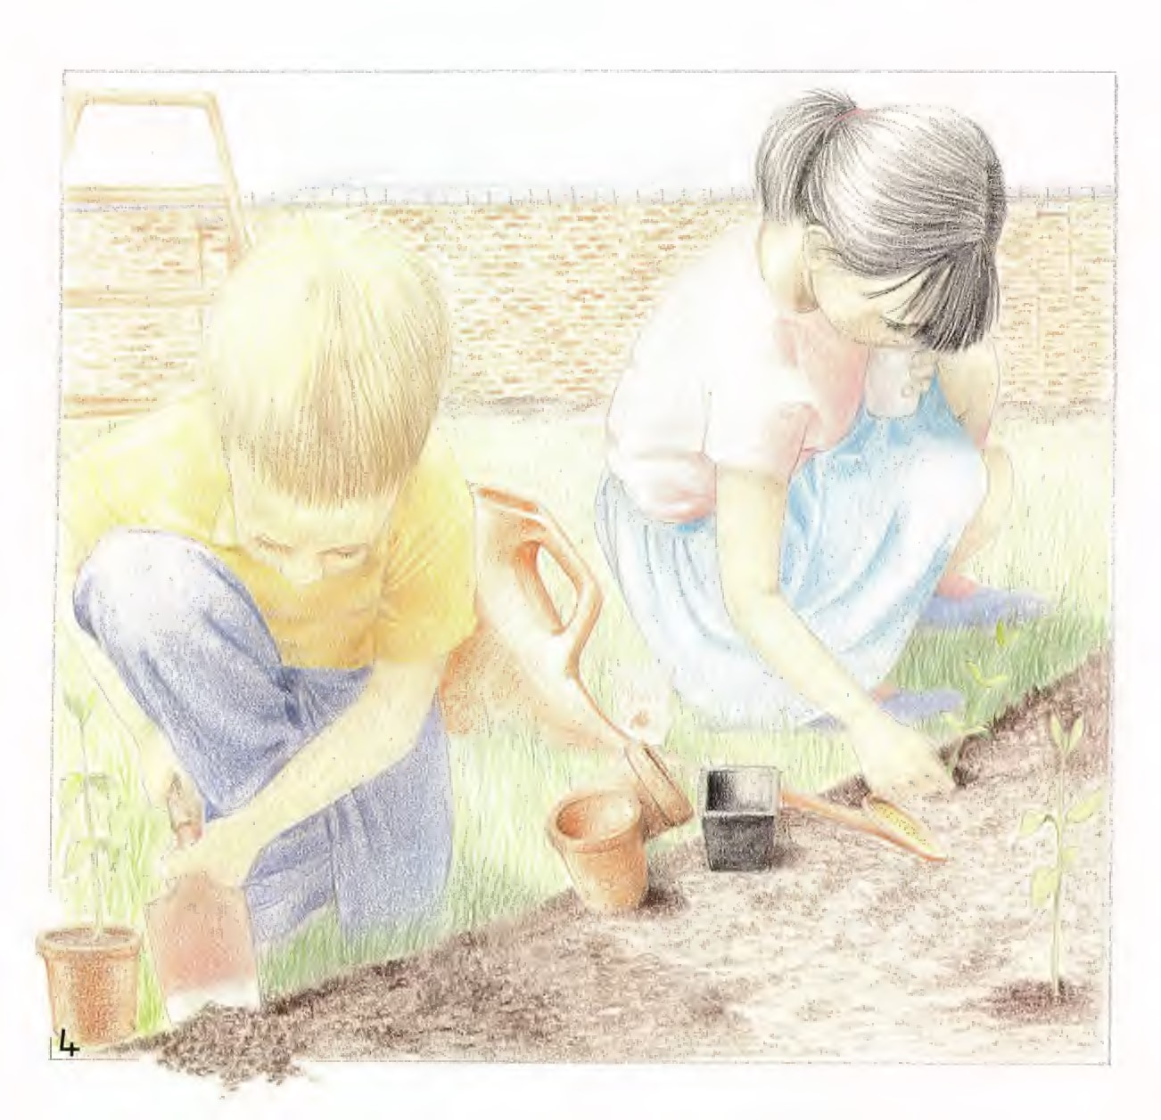
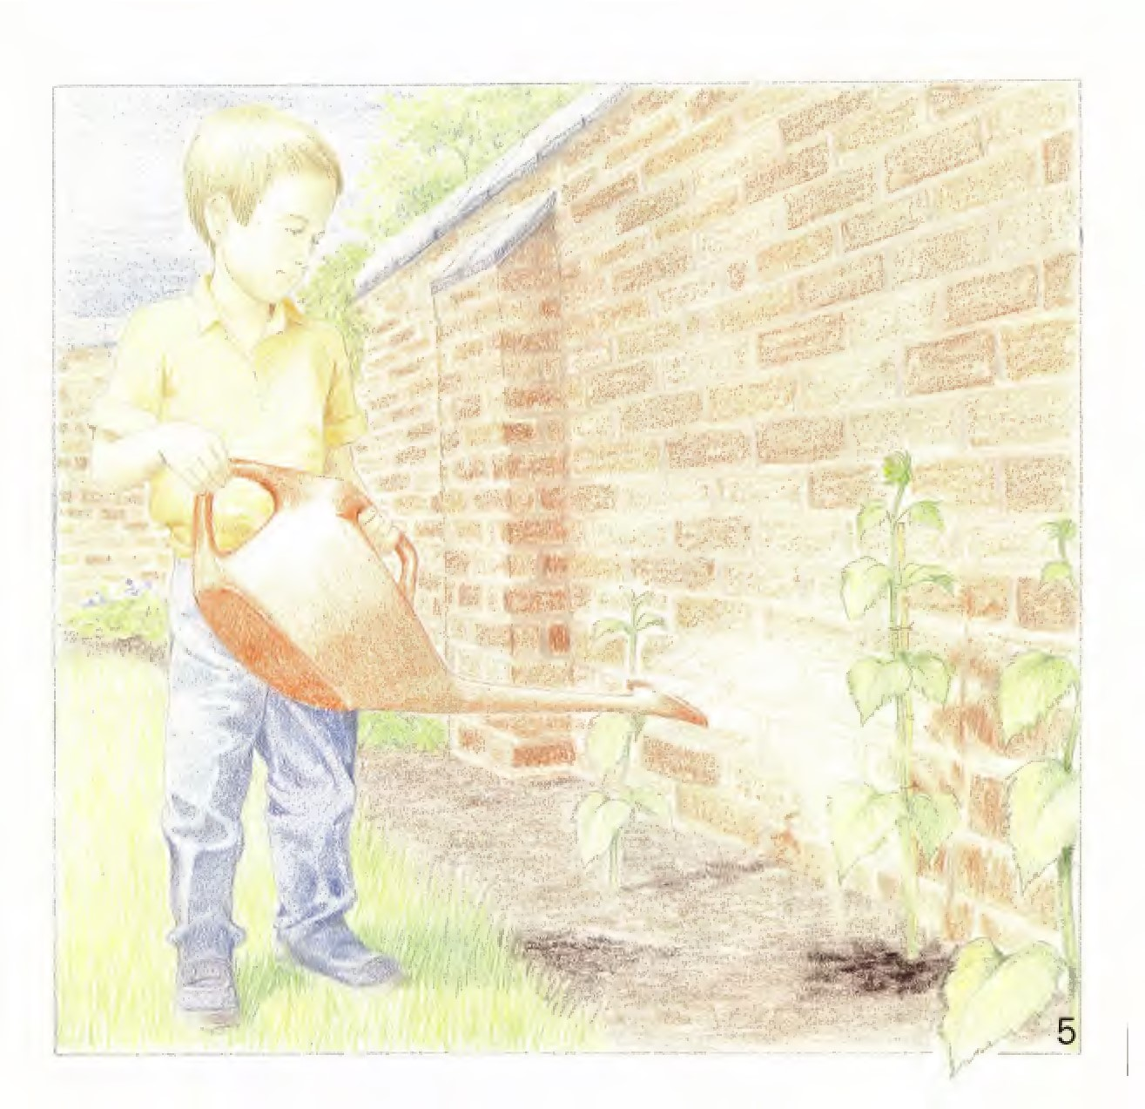
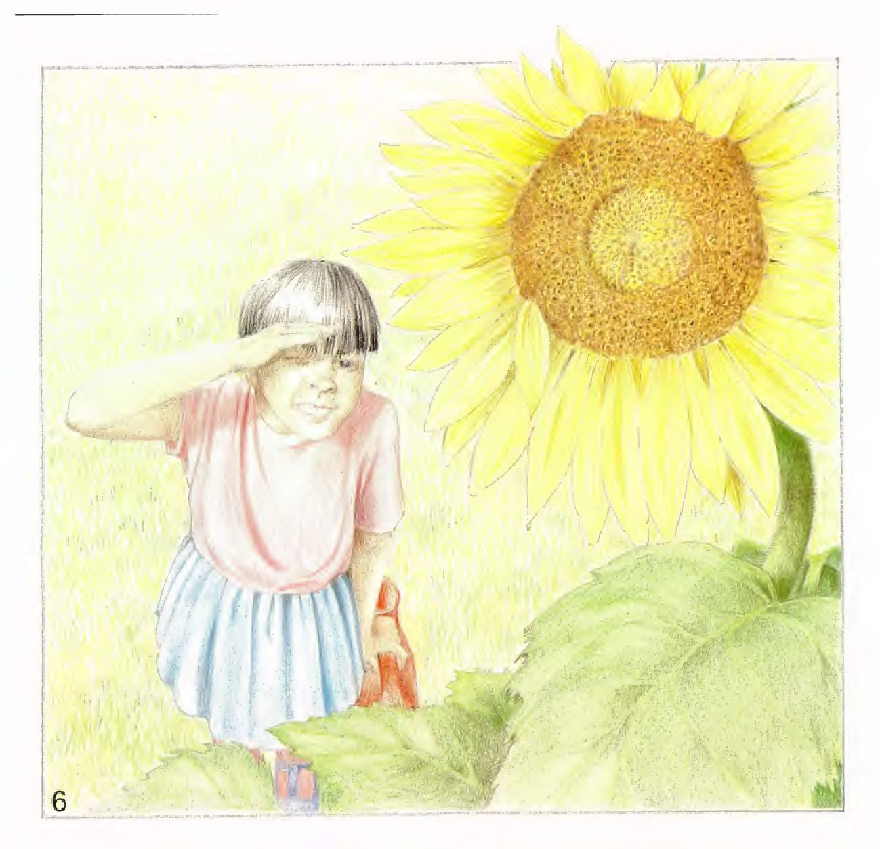
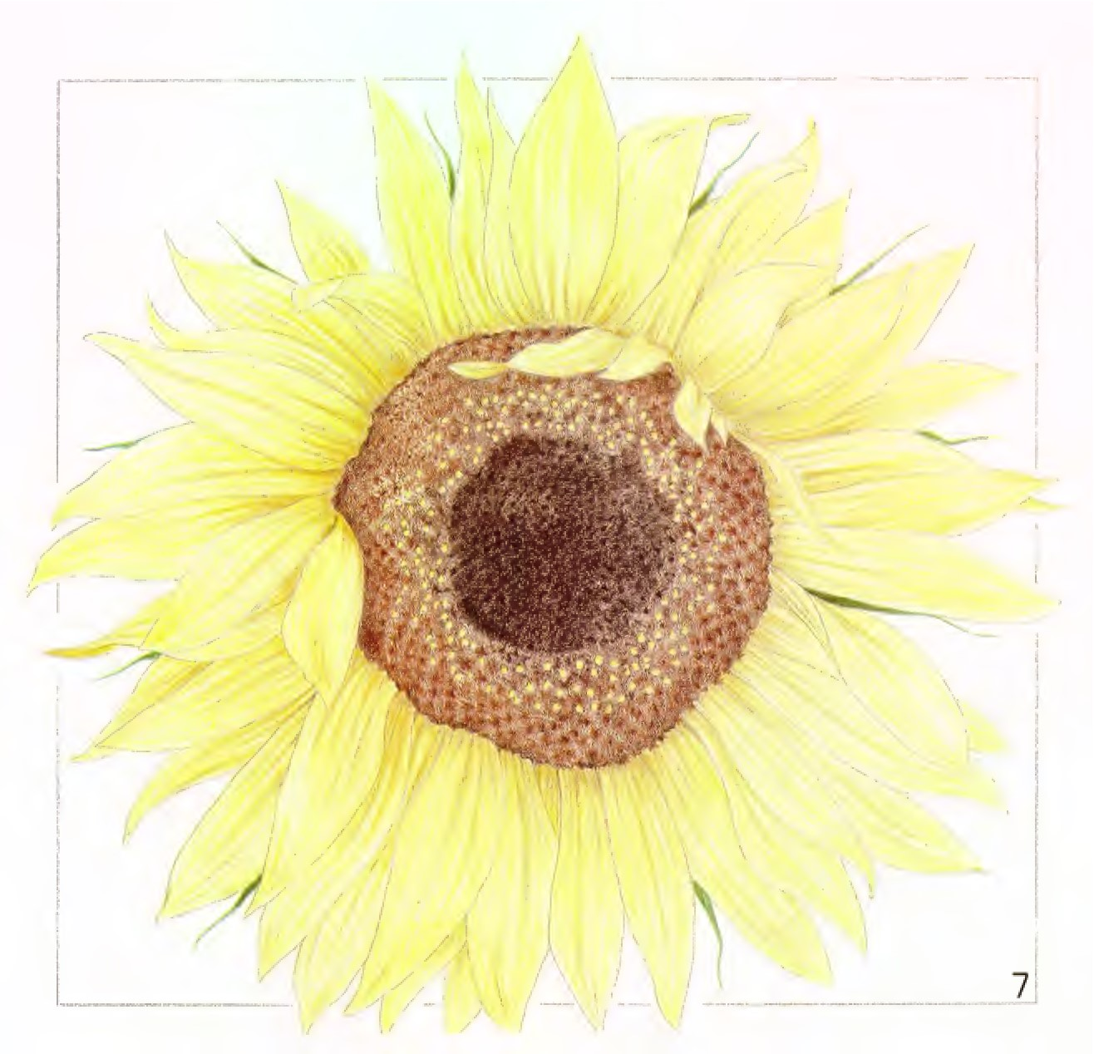
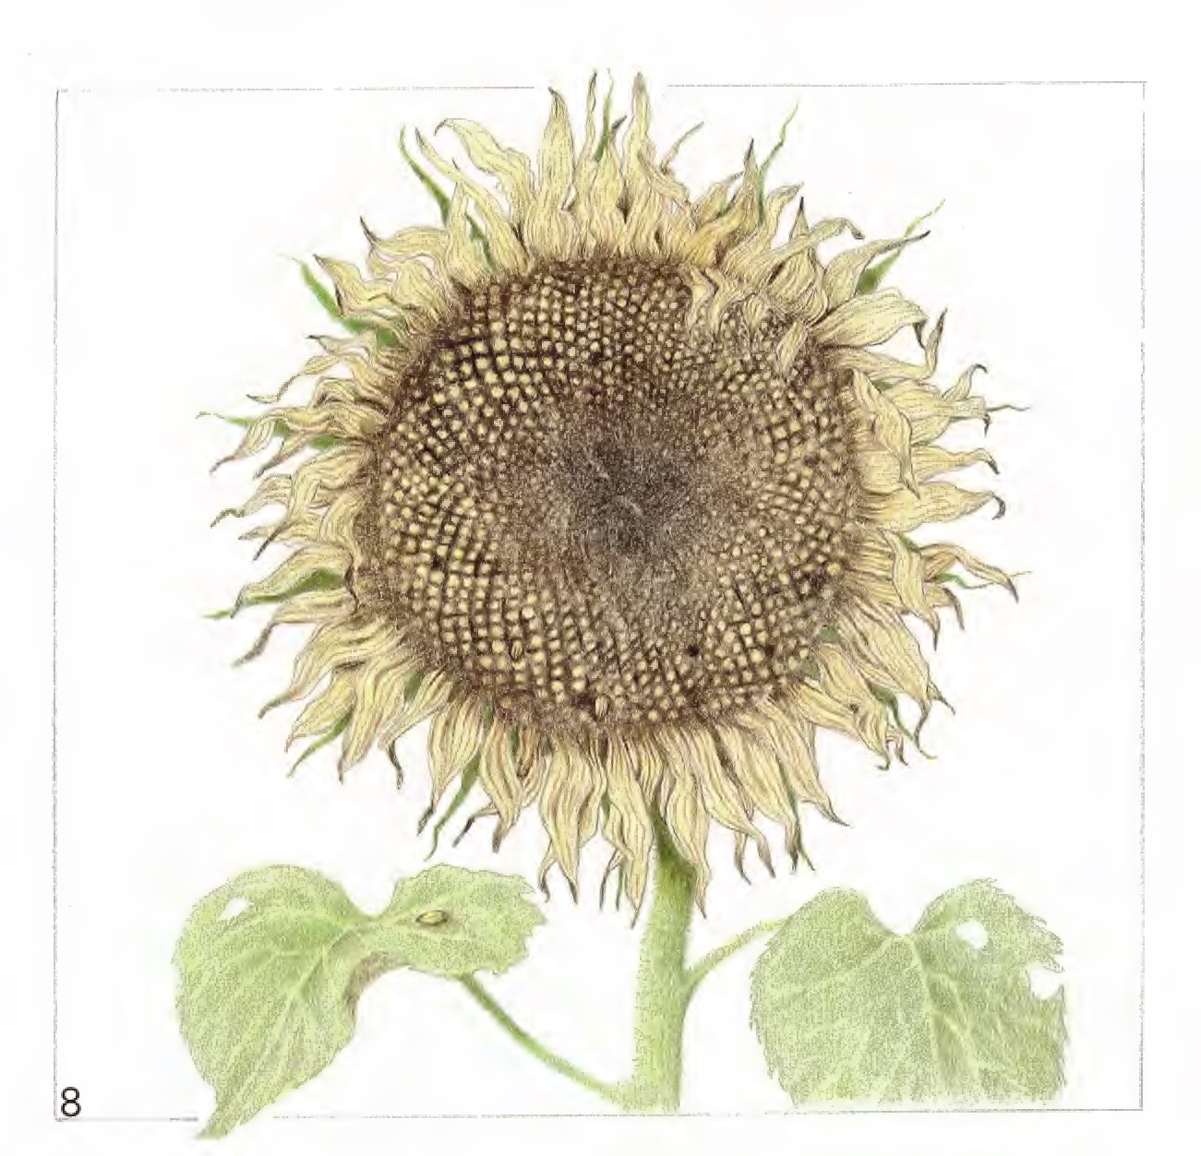

This book is copyright and reproduction of the whole or part without the publisher's written permission is prohibited.
Cinn and Company Ltd 1988
088803 story book pack ISBN 602 22925 1
Published by Gtnn and Company Ltd
Prebendal House, Parson's Fee. Aylesbury, Bucks. HP20 20Z
Printed in Great Britain by Heanor Gate Printing Limitedi Derbyshire

Ginn Science Level 1
The sunflower
Other story books in this strand at Level I
My hamster
Birds' nests
Content strand
Other animals and plants
