Maths Week Four.

This week your Maths learning videos are on the BBC Bitesize website 8th, 9th and 10th June and the learning sheets are below. The learning sheets can be accessed through the BBC Bitesize if you would like to download them directly. The learning also links with the White Rose videos if you would like to watch in more detail. On the White Rose website, the links are with Summer Term, Week 7, 8th June, Session 1, 2 and 3. Remember you do not have to do it all each day - just have a go at some of the activities.
Session 1.
Warm up | Watch and join in with the count in twos forwards and backwards video on BBC Bitesize, 8th June.  Or count in 2s with your favourite counting in 2s video:  https://www.youtube.com/watch?v=GvTcpfSnOMQ
Main activity | Go to the BBC Bitesize website, Maths daily lessons 8th June ‘Counting in 2s’.  https://www.bbc.co.uk/bitesize/articles/z693rj6  Follow the activities on the screen. Then complete the learning sheets below.  There are also extra activities/videos on White Rose website, if you would like to do those too!  https://whiterosemaths.com/homelearning/year-1/
Game | See if you can burst the balloons skip counting in 2s.  http://www.sheppardsoftware.com/mathgames/earlymath/BalloonPopSkip.htm
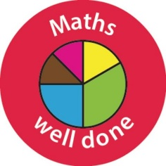 Well done Year One!

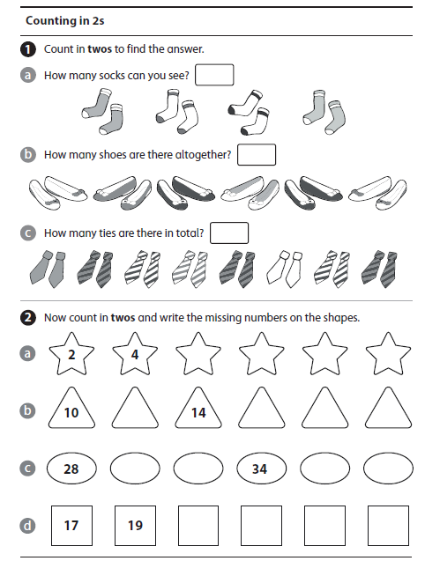

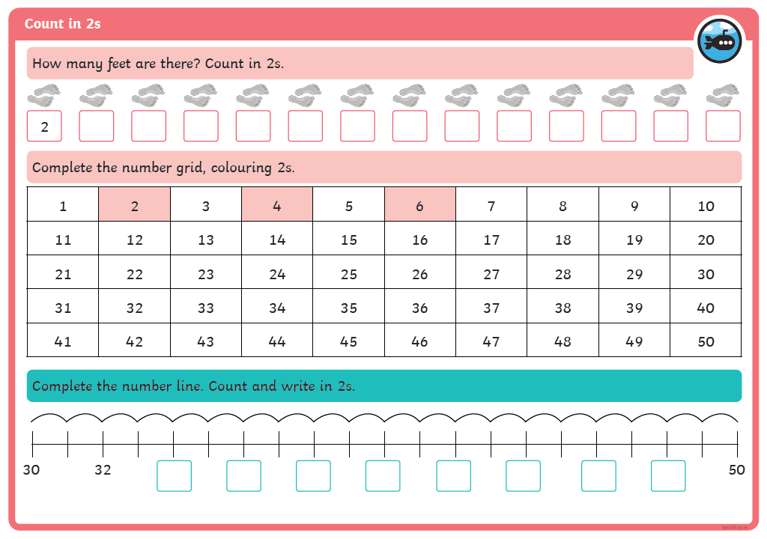
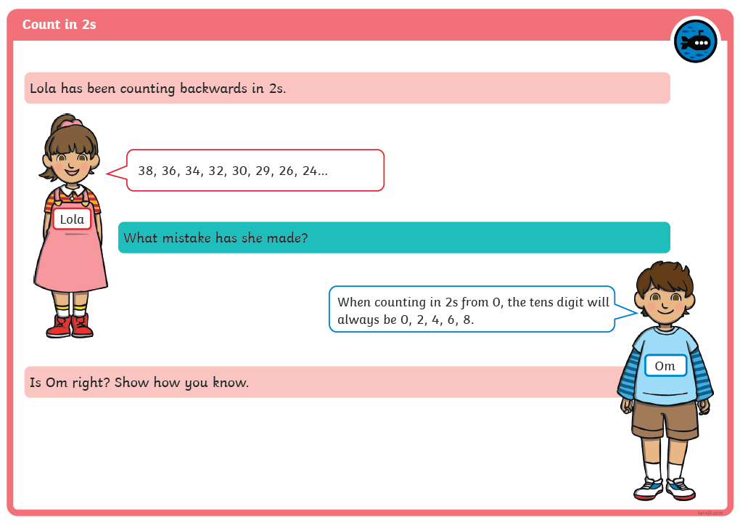
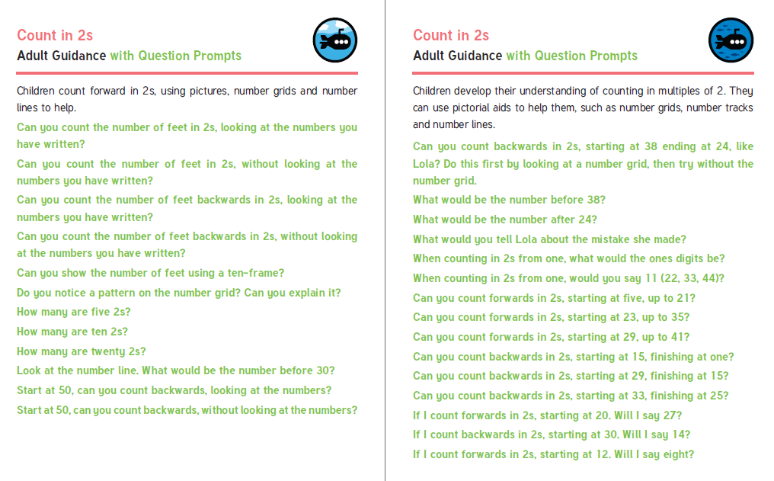

Session 2.
Warm up | Watch and join in with the count in fives forwards and backwards video on BBC Bitesize, 9th June.  Or count in 2s with your favourite counting in 5s video:  https://www.youtube.com/watch?v=EemjeA2Djjw
Main activity | Go to the BBC Bitesize website, Maths daily lessons 9th June ‘Counting in 5s’.  https://www.bbc.co.uk/bitesize/articles/zkvhscw  Follow the activities on the screen. Then complete the learning sheets below.  There are also extra activities/videos on White Rose website, if you would like to do those too and be super learners!  https://whiterosemaths.com/homelearning/year-1/
Game | Can you paint the squares counting in 5s?  https://www.topmarks.co.uk/learning-to-count/paint-the-squares

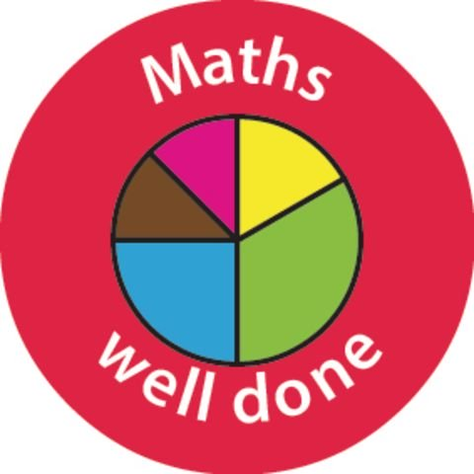

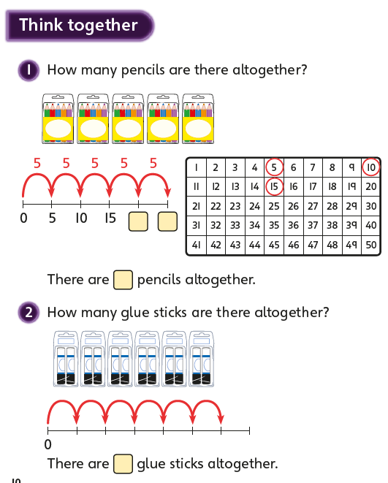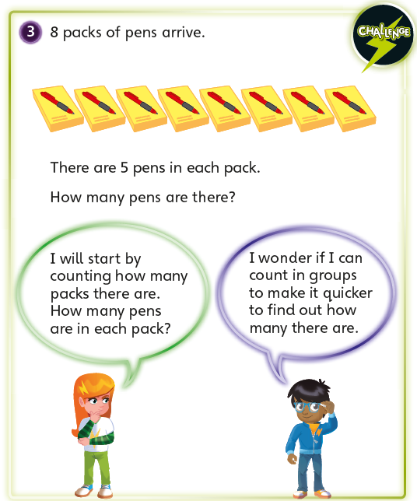
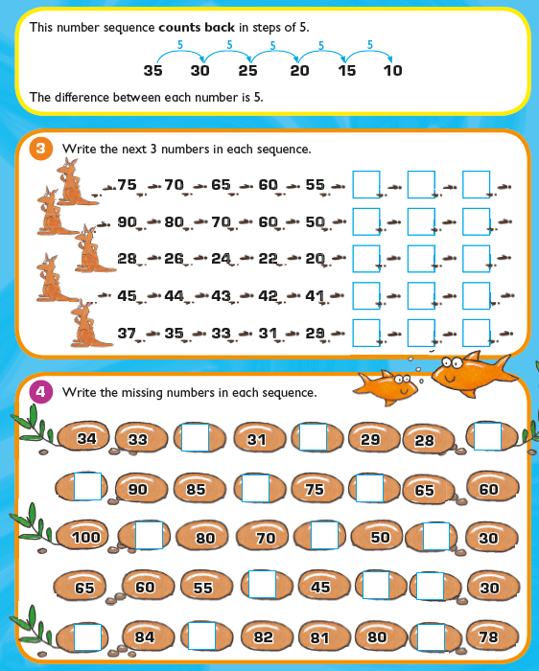

Session 3.
Warm up | Watch and join in with the count in tens forwards and backwards video on BBC Bitesize, 8th June.  Or count in 10s with your favourite counting in 10s video:  https://www.youtube.com/watch?v=Ftati8iGQcs
Main activity | Go to the BBC Bitesize website, Maths daily lessons 10th June ‘Counting in 10s’.  Follow the activities on the screen and do the practice activities. Then complete the learning sheets below.  There are also extra activities/videos on White Rose website 10th June, if you would like to do those too!  https://whiterosemaths.com/homelearning/year-1/
Game | Can you paint the squares counting in 10s?  https://www.topmarks.co.uk/learning-to-count/paint-the-squares

Well done Year One! You have done so well this week.

