- My favourite snack is a jam ____________!
Words which contain the letter-string ‘ough’

Use these words to complete the sentences below…
bought, cough, dough, plough, enough, thorough, doughnut.
Have a dictionary or access to the internet nearby so that you can check the meaning of the words to fit them into the sentences below!
Year 5 – Week 1 - Spellings
- I ____________ a bag of sweets with my pocket money.
- The farmer had to ____________ his fields.
- Yesterday I could hardly speak, I had a really bad ____________.
- The teacher did a ____________ search, but they could not find the missing coat.
- Before I add the toppings to the pizza, I have to make the ____________.
- The meal wasn’t ____________ to eat so he just had to have a dessert!
Write a paragraph using as many -ough words as you can! Try and make it as silly as possible!

Spelling, Grammar and Punctuation Challenge Tasks:
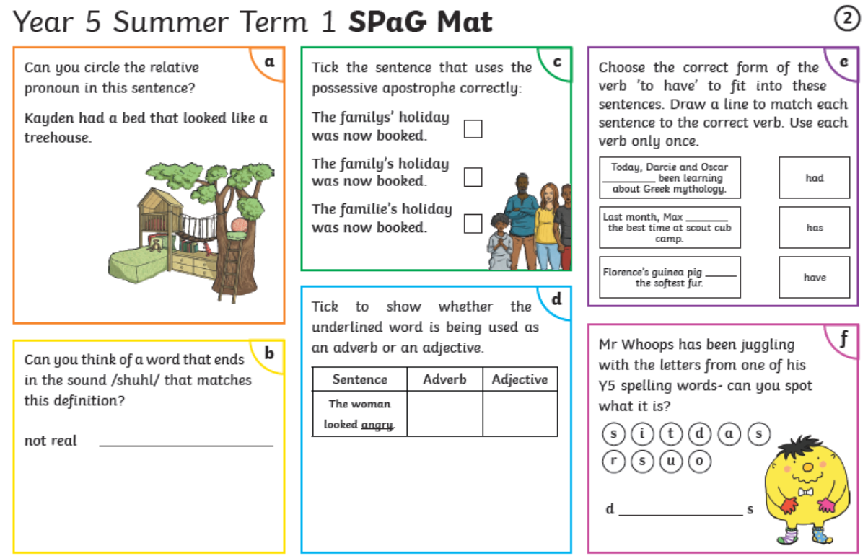
Year 5
Reading Activity – Week 1
LO: We are learning to increase our familiarity of a wide range of stories, including legends and traditional stories.
Please complete the questions below:
- Read ‘The Hare and the Tortoise’ (on the next page) try and read it aloud or with a family member.

- Why do you think the Tortoise wanted to take part in the race?

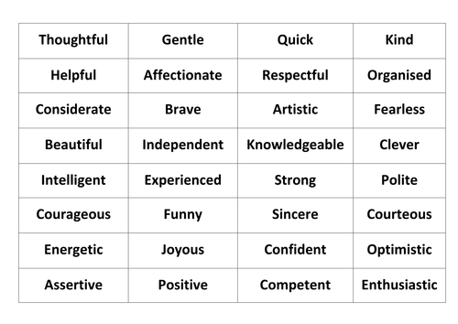

- Can you write down 3 words to describe the character of the Tortoise and 3 words to describe the character of the Hare? Choose from the words on the right or you can come up with your own!

- How do you think the Hare felt at the end of the race? Why?

- The Hare and the Tortoise is a fable, fables are very old stories that often contain a fantasy (such as talking animals!) and have a moral. What is the moral to this fable?

- How could you apply this moral to your life? (e.g. I could try and think about my writing before having a go or take more time on a piece of artwork)

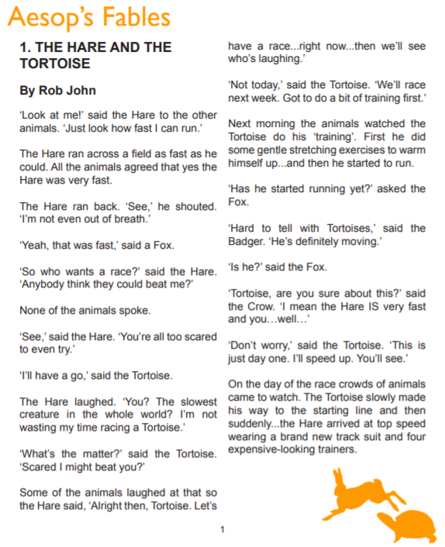

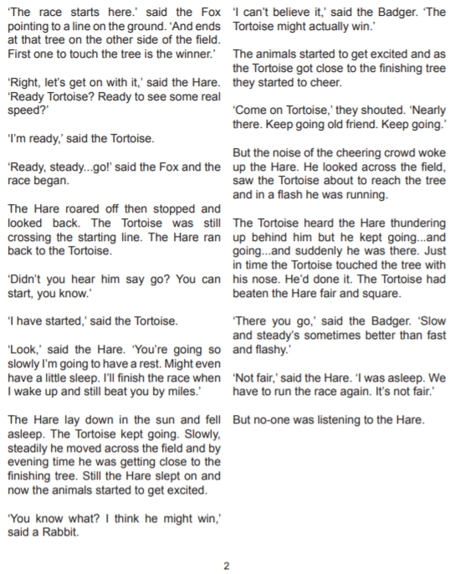

Year 5
Writing Activity – Week 6
Learning Objective:
We are learning to develop our ideas by drawing on prior reading.

This week our focus on writing is ‘Traditional Tales’. Unlike Fables, these don’t have to have a moral at the end.
It is about time that we heard the other side to the stories! Choose a different or unusual way of introducing these well-known fairy tales (or choose a fairy tale from the options below) and rewrite the rest of the story in the same style. The idea is to write a ‘Fractured Fairy tale’ by writing it from a different perspective, was the evil Stepmother really that evil, or was she misunderstood? How about the Beast, how did he feel about the whole thing?

Three Little Pigs – Everybody knows the story of the Three Little Pigs. Or at least they think they do. But I’ll let you in on a little secret. Nobody has heard MY side of the story.

Red Riding Hood - So, there I was, minding my own business, when I saw that little thug, Red Riding Hood. She was wearing an evil grin and I could see a nasty glint in her eye.

Snow White - There I was, a sweet, innocent Queen, being told that I wasn’t the fairest in the land! How did this happen? I hear you ask. Well, I’ll tell you. But be warned… this isn’t the story of Snow White that you’ve been told. Oh no.

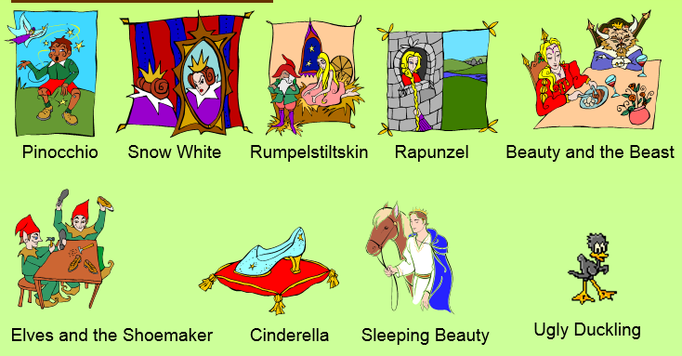
Planning sheet for your ‘Fractured Fairy Tale’
