Spelling Activity – Week 5
LO: We are learning to spell our year 5 and 6 spellings correctly.

Have a look at the spellings below, and highlight/ colour in 8 words that you think you find tricky to spell! These are the words that you will be focussing on this week, do not choose more than 8 as it will be hard to remember them all! Then complete the two spelling activities on the next few pages, using your chosen words.
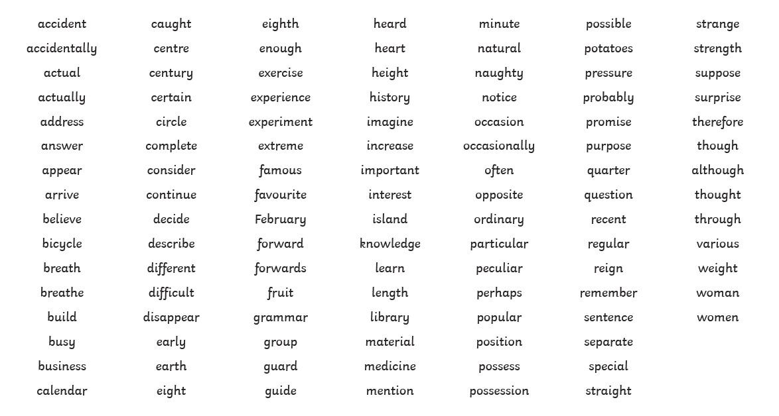
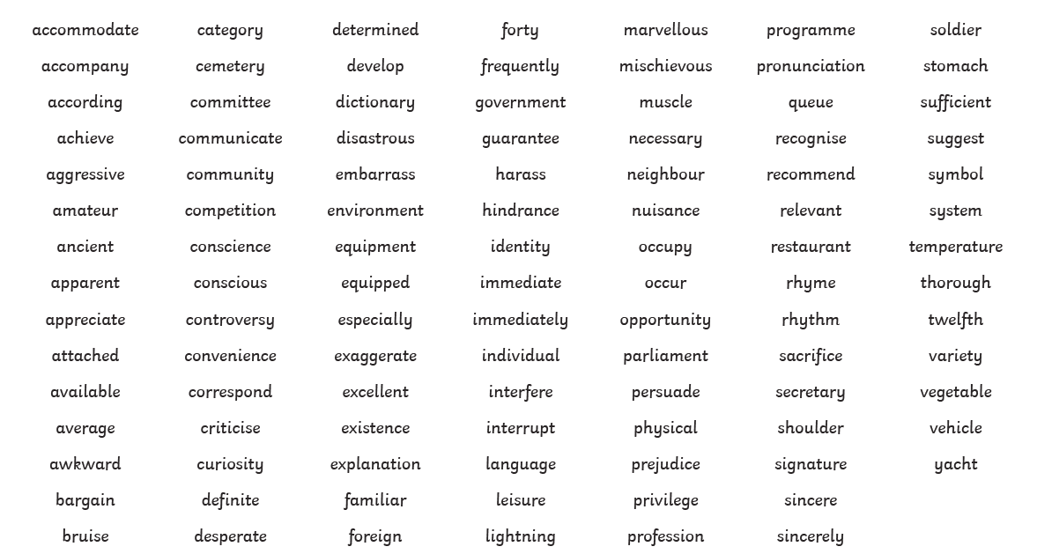
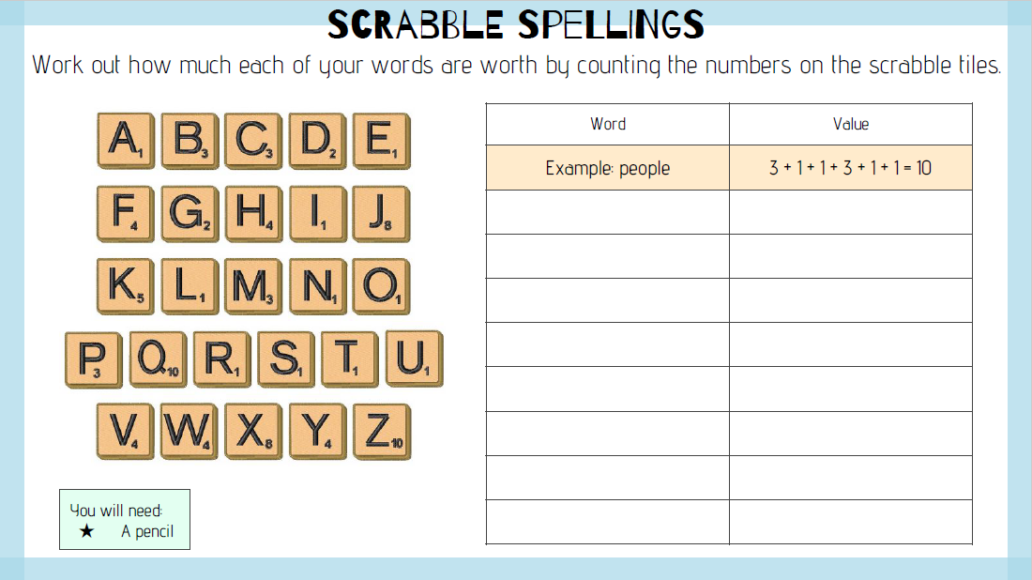
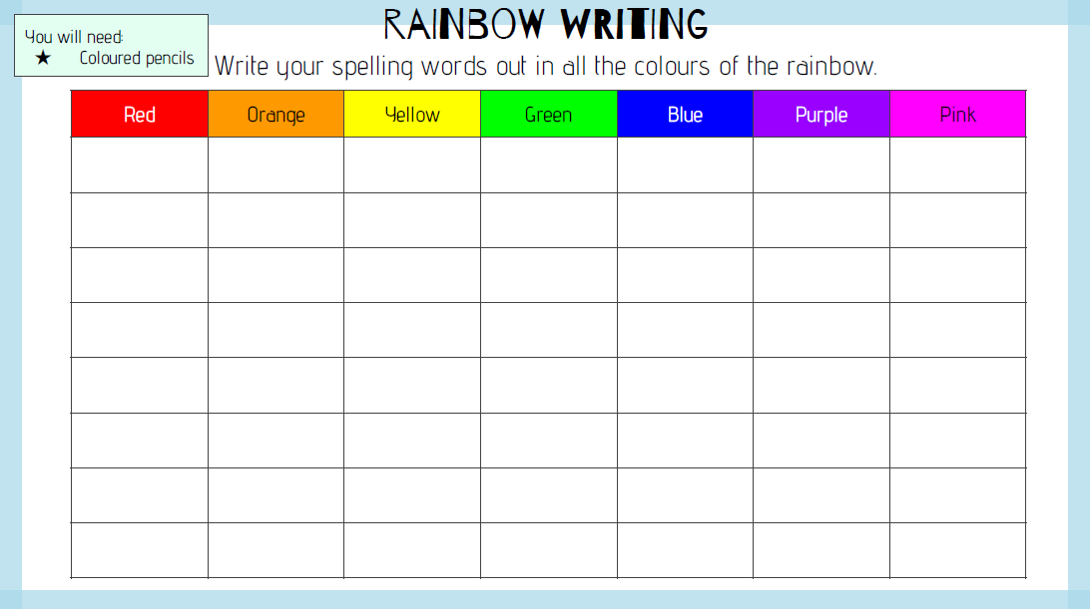
SPaG Challenge
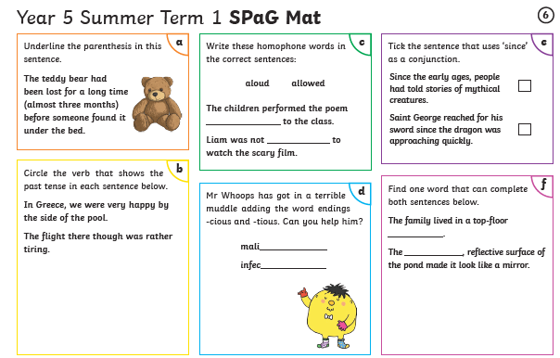
Year 5
Reading Activity – Week 5
LO: We are learning to discuss and evaluate how authors use language.
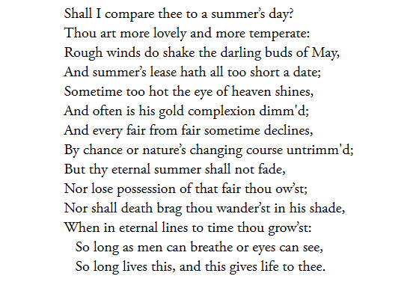
This week, we would have been focusing on Twelfth Night, by Shakespeare. For your reading task today, read the sonnet (a 14-line poem with a set rhyme scheme) by Shakespeare below and then answer the questions.

Have a go at filling in the table below, either use the internet, ask an adult or have a go at writing the meaning by using the context of the words in the sonnet above.
Text | Meaning
Thee
Thou art
Lease
Thy

- What do you think of when you think of a summer’s day?

- Why do you think Shakespeare compared a person to summer’s day?

- What do you think the poem is about?

- What is your favourite phrase from the poem? What do you think it means?

Year 5
Writing Activity – Week 5
Learning Objective:
We are learning to use a range of punctuation in our writing

The theme of your project is transition. For your writing, write a letter to your Year 6 teacher (Miss Dodd or Miss Revels-Hull).

What can you write about in your letter?
- A bit about yourself – your hobbies and clubs/ family
- Your favourite subjects/ what you find challenging at school
- Your favourite author/ book
- What you are looking forward to in Year 6
- Your hopes and dreams for Year 6 and beyond

Make sure you read through and check your punctuation, try to include the varied punctuation below:
