Year 1 Phonics Activity 2.
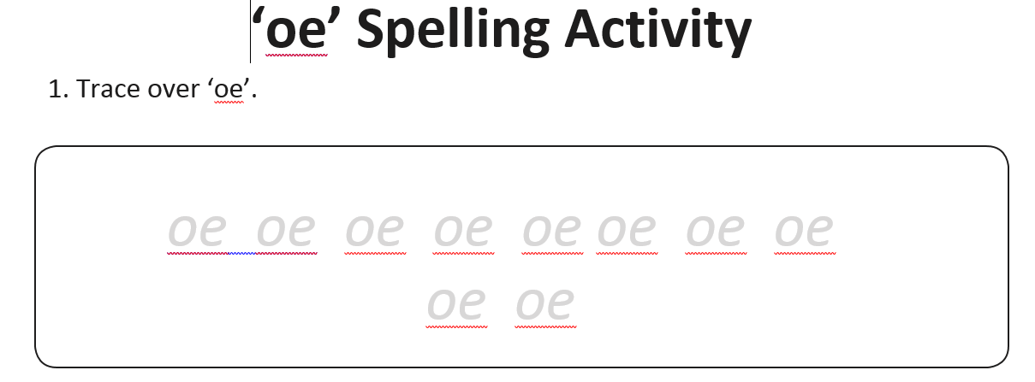

Can you write the ‘oe’ words under the pictures?
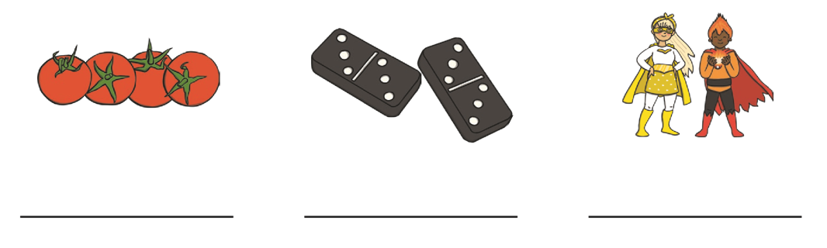

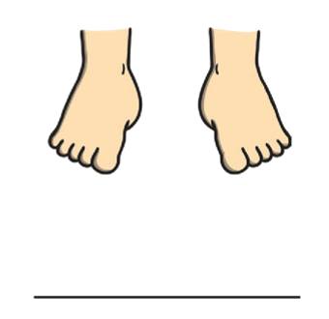

Challenge – can you think of a word using ‘oe’ and draw your own picture in the box above?
Be careful not to use a split digraph ‘o-e’ sound or ‘oa’- get a grown up to help if you are stuck! Think of one of your own but if you need help here is a clue! (Clue: vegetables used to make chips)
Now try o-e! These words sound the same but use the split digraph o-e to make the word.
- Just add ‘o-e’ in the correct place to the words below. Now, choose three of the words, draw a picture and write a sentence to say what they are.

1. 2. 3.

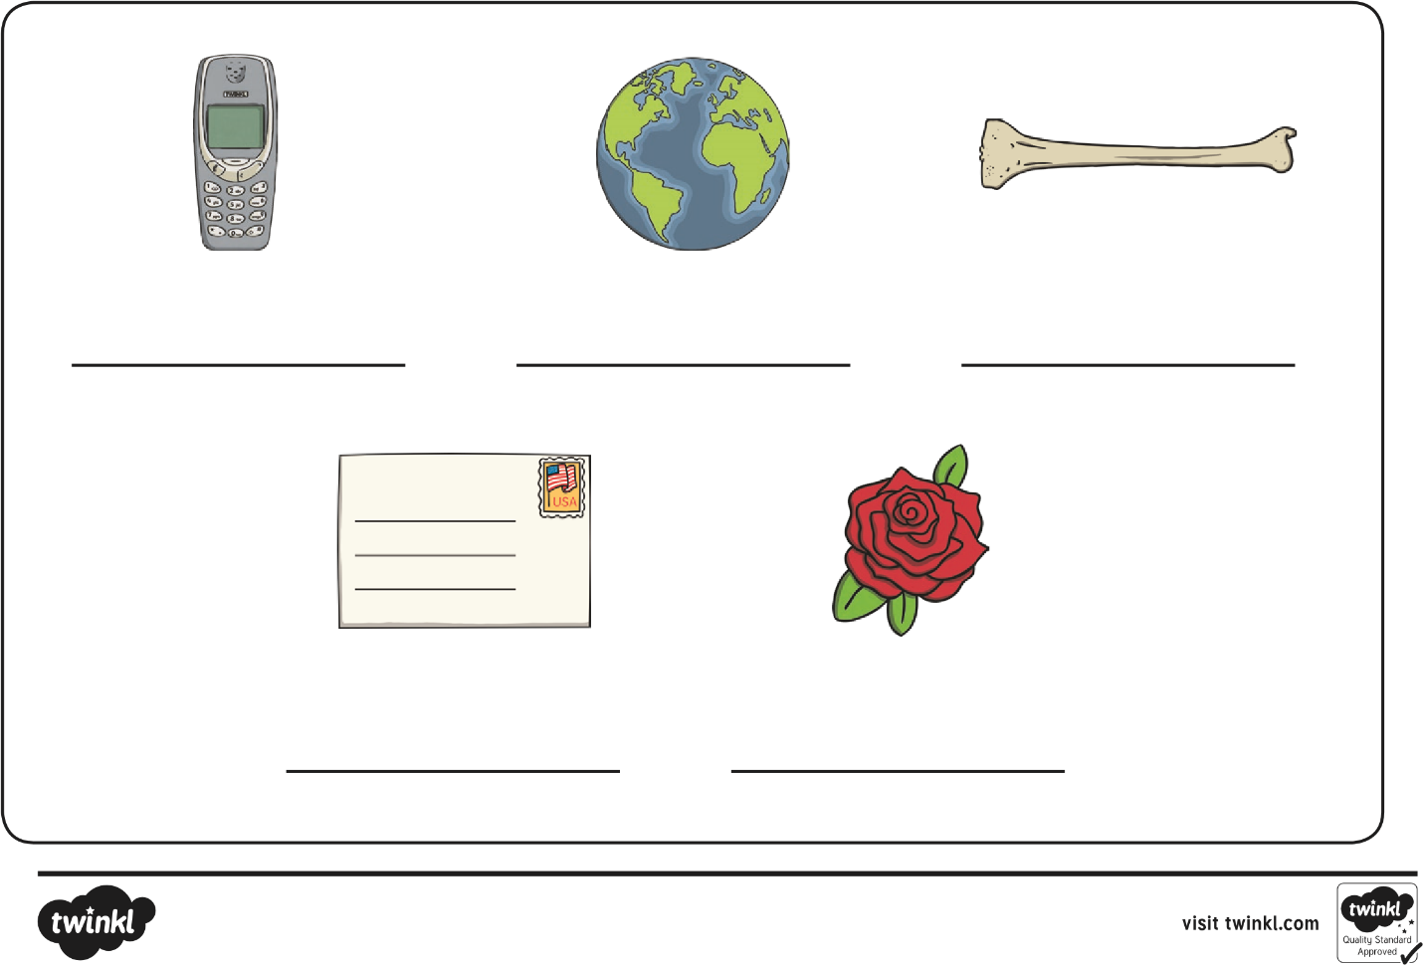
Look at the pictures and write the o-e in the words below.

Year 1 Phonics Activity 3. LO: To understand how to use ‘o-e’ to spell words correctly.
Can you write the missing words below the picture?
Next can you write a sentence for each ‘o-e’ word on the lines below?
CHALLENGE – can you write a sentence containing more than one of the ‘o-e’ words, maybe two or three in one sentence? Good luck! Finally- colour in the pictures!
