Making instruments out of VEGETABLES
Here are some videos of musicians making and playing instruments out of veg! I thought it was fun and entertaining.
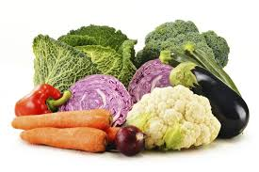

PLEASE DO NOT MAKE THESE WITHOUT A GROWN UP!

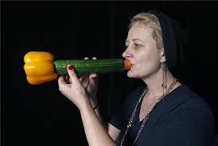

https://www.youtube.com/watch?v=xM1EjIDLMLY
https://www.youtube.com/watch?v=ezgYuEMzWlo
https://www.youtube.com/watch?v=E3Msi24KKHo
Have a go at making instruments out of random household objects? Can you make edible instruments?

