Week 3: Sports Week Overview

As you may have been aware, Sports Day was due to take place this week. Whilst this cannot take place in the usual way, we are still very keen to ensure the children still have opportunities to take part in sports activities throughout the week and most importantly to have fun and feel part of a team. Mr Howick and our SSA have been very busy planning a range of activities and events to take place throughout the week, including the following:

1. Daily diet and fitness challenges: choose one diet challenge and one fitness challenge for each day. You will find lots of ideas in the menu e.g. Day 1, 100 squats and 2L of water etc. See pages 2-3 of this document.

2. House km Competition supported by the SSA’s Summer Family Fun Run: We will be using this event as an opportunity to hold a House Competition – a significant part of our usual Sports Day and something that the children love to be involved in. In addition to this, the SSA have organised a fantastic fundraiser event – please see their flyer below for more details. Children can send their total weekly distance (bikes, running, walking, scooters etc) with the name of their house (Roman, Tudor, Celtic or Victorian). We will then total up the scores from each house; the house that has travelled the furthest distance wins. See pages 4-5 of this document for further details.

3. Home/Park Sports Day: tailored sports day activities you can complete in your garden or at home. Please see links to instructional videos, a scoring system, description of activities and a scoring chart on pages 6-12 of this document.

4. Healthy Selfie: A picture of the children in action either cooking healthy meals or mid exercise. Please see page 13 of this document.
1. Daily Diet and Fitness Challenges
Can you complete one fitness challenge and one diet challenge each day?

Drink 2L of water | Eat 5+ fruits and vegetables | Complete the SSA Fun Run & House Competition (more details below on pages 4-5)
Try a new vegetable | Complete 100 squats | Get 10-11 hours of sleep
Complete 50 sit ups or press ups | Cycle or scoot 5km | Hold a plank for over 1 minute
Design/make your own healthy salad | Help cook a healthy meal | Complete over 10,000 steps in one day
Try a day without sweets, crisps or chocolate | Complete an hour of physical activity. | Eat a nutritious breakfast

Select a physical and dietary challenge and place them in the calendar on the next page

Daily Diet and Fitness Challenge Calendar
 | Diet challenge | Fitness Challenge
Monday
Tuesday
Wednesday
Thursday
Friday
What can you achieve this week?

2. Saxon House Km Competition
Monday 15th - Thursday 18th June.

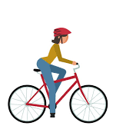
A house competition is a key part of our usual Sports Day events and something the children love to be involved in. For this competition, simply record the total distance (km) you have travelled on your bike, by foot or on your scooter (including the distance you have travelled during the SSA Summer Family Fun Run – see below), using a running app or fit bit. Then add the distance you have travelled to the Google form link below, where it will be added to your house’s total. Please could all distances be recorded on the form by midnight of Thursday 18th June. The house that has completed the furthest combined distance will be the winner. Saxon staff will also be competing for their house and included in the competition.
Google Form Link: https://docs.google.com/forms/d/e/1FAIpQLSdMyGPd1An0kW6oZpSCj2eAUvj_ZVNW0S1InjIyAxjzJpiK5Q/viewform?usp=sf_link
Apps to track your distance:
Nike Running Club
Strava Running and Cycling
MapMyRun/MapMyWalk

The houses are: Roman, Tudor, Celtic & Victorian. If your child is unable to remember which house they are in, please send an email to learning.saxon@lumenlearningtrust.co.uk and Miss Doherty or Mrs Hartshorn will be more than happy to help you.
2. SSA’s Summer Family Fun Run
SSA Summer Family Fun Run 🏃‍♀️🏃🏼🏃🏻‍♂️☀️🌤🌈
This is probably the SSA‘s only opportunity to raise funds for school during lockdown. Our aim is to raise £500+ for a Sensory Garden to help the children
re-adjust to school life in the Autumn Term and to be a valuable resource in the future. Thank you for your support and have fun!

- WHEN: Anytime w/c 15th June 2020
This would have been the week of ‘Sports Day’.
- RULES: Do it socially distanced and safely but whenever and wherever you choose.
- HOW: Run or walk, hop, skip, cartwheel... cycle or swim! You can go as far as you would like!
- PRIZES: For fancy dress, crazy outfits and for making it as memorable as you can!
- WHO: Everyone is welcome to join in to get fit and have some fun. There is no need to donate to enter.

- DONATIONS FOR SENSORY GARDEN: If you are able, you can sponsor runners by km or by family. Online donations only at:
https://www.eventbrite.co.uk/e/ssa-summer-family-fun-run-tickets-108957719472?ref=eios
(NB. We’re using this system so we don’t incur setup costs.)
- PHOTOS/VIDEOS : Send to ssa.saxon@lumenlearningtrust.co.uk for use on the School Facebook site. Please note that by sending in, we will assume you give permission for use on the School Facebook site.
Prizes for winners will be delivered or given out at school as appropriate. Sponsorship money in by 30 June 2020 please.
Please note, the distance you run for this sponsored event can be included in your total score which contributes to the House Competition.
3. Home/Park Sports Day
Sports Day Scoring Sheet:

Choose some events and place your name and your family members’ names across the top. Details of the activities can be found on the next few pages. Good luck!

Events | Name: | Name: | Name: | Name: | Name:
Target throw
Standing long jump

Egg and spoon race
Sack Race

Obstacle course

Speed bounce

Scoring:
1st= 3 points
2nd= 2 points
3rd = 1 point

Activity 1: 60 Second Target Throw:

Steps:
- Place a target on the floor.
- Stand three large steps (around 2/3 metres) away
from the target.
- Throw the object into the target
- Collect the object and return to the start line
- Repeat as many times as possible in 60 seconds
- Keep a running total of how many times you hit
the target.

Top tips:
Stand facing the target. Keep your feet shoulder width apart and point at target with your weaker hand. Bend your elbow at a 90-degree angle and throw.

Equipment:
A beanbag and a hoop.
If you do not have a beanbag or a hoop, why not use a pair of socks, a tennis ball, or scrunched up paper and a washing basket instead.

Example Video link: https://www.youtube.com/watch?v=tHRvquNKf1Q&list=PLYGRaluWWTojV3An2WEgsQ4qGFy_91jDL&index=5&t=0s

Activity 2: Standing Long Jump:
Steps:
- Place a starting marker on the floor
- Jumper 1 to stand still behind the starting marker
on two feet.
- Jump as far as possible
- Place another marker behind the back foot of
Jumper 1 or measure using tape.
- Jumper 2 to repeat steps using a different
marker.
- The person who jumps the furthest wins.

Equipment:
Tape measure
If you do not have a tape measure, you can mark the distance using cups, controllers or any object.
Top tips:
To jump further, keep your head up, swing your arms and bend your knees when taking off and landing.

Example video link:
https://www.youtube.com/watch?v=Dc-y0H6VNLk

Activity 3: Egg and Spoon Race:
Steps:
- Create two lines: a start/finish line and a turnaround point.
- Each player gets a spoon and an egg
- They must carry their egg on their spoon from the starting
line to the turnaround point and back again.
- If the egg falls they must return to where it fell and
place it back on the spoon.
- The first person who crosses the finish line wins

You could add obstacles to increase the challenge

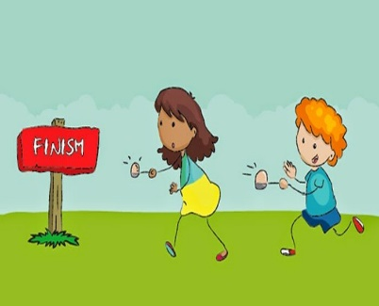

Equipment:
An egg and spoon.
Alternatively, you could use a small potato, ball or scrunched up paper.

Top tips:
Do not try to move too quickly; start by walking slowly in a straight line. Next, try a gentle jog and then work up to a run.

Activity 4: Sack Race
Steps:
- Create two lines: a start/finish line and a turnaround
point with a marker.
- Each player puts both legs into sack
- Jump as fast as possible around the marker and
back again
- The first person across the finish line wins.

You could do this as a relay race if you have four
or more people.

Equipment:
2+ sacks
A large carrier bag, pillow case or a bin bag can be used for this activity.

Top tips:
Keep your legs slightly apart and bend your knees to jump further.

Activity 5: Obstacle course
Steps:
- Create an obstacle course using a range of
household items
- Try to include crawling, jumping, running
and climbing.
- Create the rules for the obstacle course
- Time each person from start to finish
- The person who completes the obstacle
course the quickest is the winner.

To make the course more challenging you could try it blindfolded.

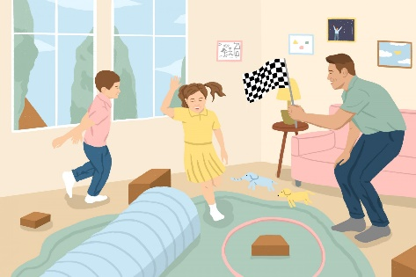

Equipment:
Stopwatch and a range of household items.
You could climb on chairs or the couch and crawl under bed sheets, duvets or tables.
Jumping:
Jumping

Top tips:
Decide the focus of the obstacle course: speed, endurance or co-ordination before starting.

Example video Link: https://www.youtube.com/watch?v=v7V_uKNvxvk

Activity 6: 60 second Speed Bounce
Steps:
- Choose someone to count and someone to jump.
- Jumper stands facing the counter to the side of the
dividing line with both feet on the same side.
- Count how many times they are able to jump over the
dividing line in 1 minute.
- The jump must be sideways and both feet must land the
other side of the line to count.
- Feet don’t have to take off or land at the same time
for the jump to count.

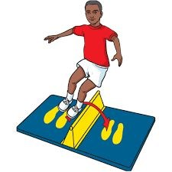

Equipment:
Stopwatch and a line
A dividing line could be made using a wire, string or socks, or you could hurdle over a rolled up towel.

Top tips:
Lift your head up, bend your knees and keep your legs together.

Example Video link: https://www.youtube.com/watch?v=jB1NWH0qpTA

4. Healthy Selfie Challenge:
Can you take the best healthy selfie?

To take part, all you need to do is take a photo (selfie) of you doing some form of physical activity or preparing/eating a healthy meal. The focus of the photo should be you (ideally smiling), the setting (park, kitchen, garden etc.) and the equipment used.
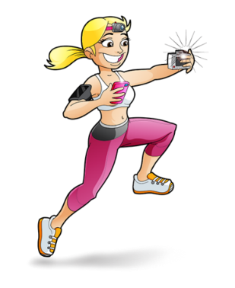
Examples:
- Eating a healthy salad
- Running around a park
- Doing the plank
- Eating a vegetable or fruit
- Playing football
- Participating in any of the Sports Week challenges or events

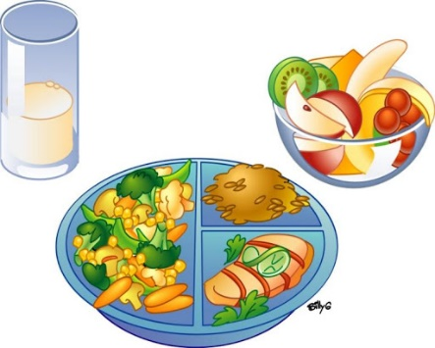
Be creative, have fun and smile!

Remember to send your pictures to
learning.saxon@lumenlearningtrust.co.uk

