Spelling Activity – Week 6
LO: We are learning to spell our year 5 and 6 spellings correctly.

Have a look at the spellings below, and highlight/ colour in 8 words that you think you find tricky to spell! These are the words that you will be focussing on this week, do not choose more than 8 as it will be hard to remember them all! Then complete the two spelling activities on the next few pages, using your chosen words.
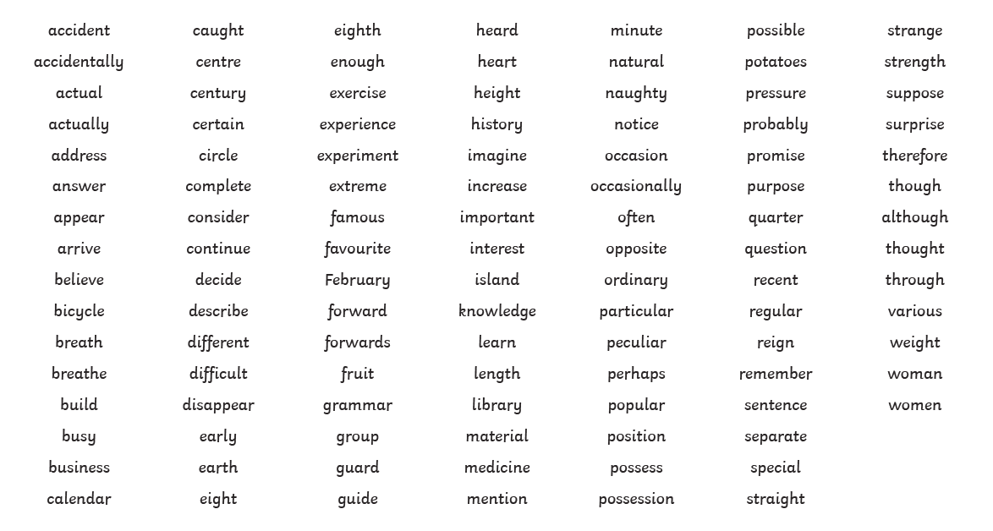
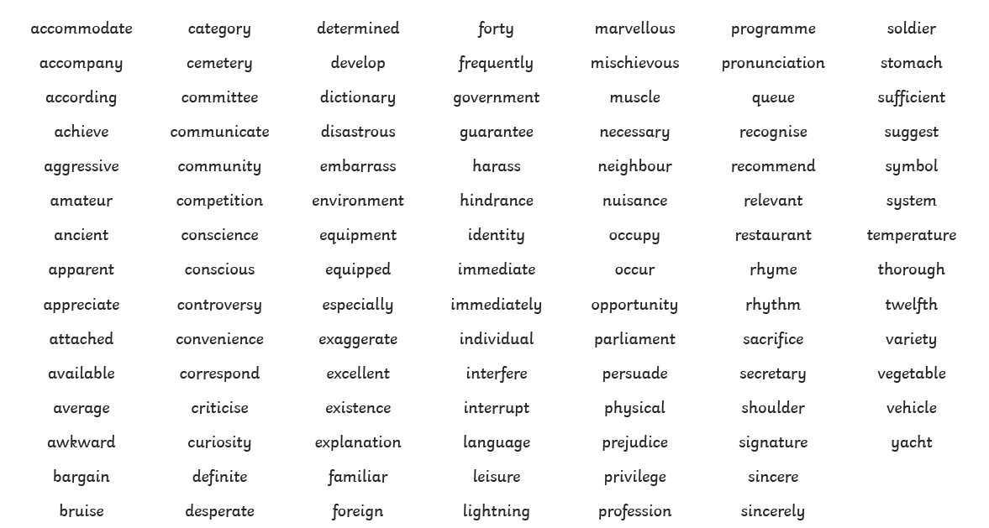
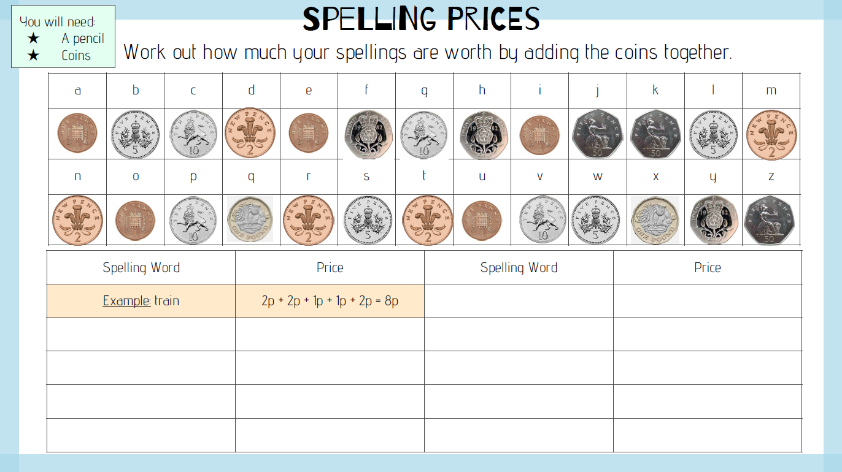
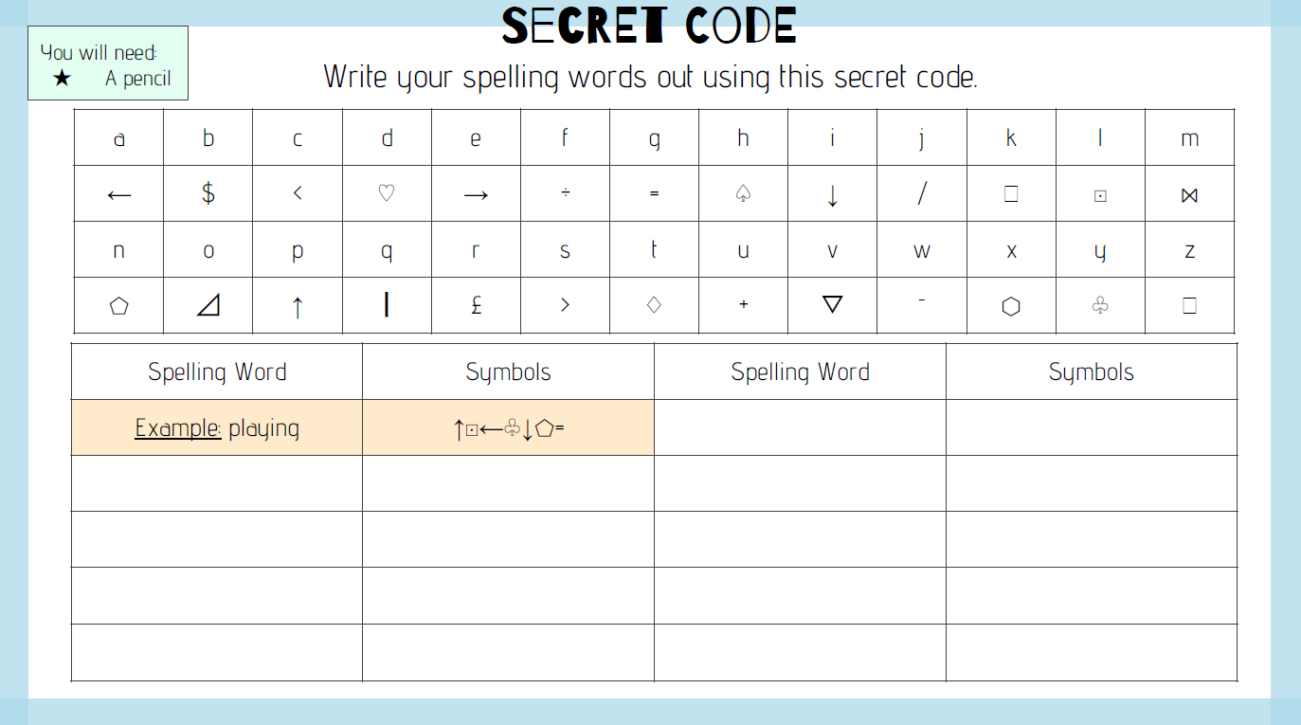
SPaG Challenge
Use the table below to help you add the correct punctuation to the sentences!
Remember, you can use brackets for parenthesis (adding in extra information). Semi colons are to join two main clauses that are closely related together, colons can be to introduce a list and a dask creates a break in a sentence!
E.g. The man walked to the shop (it took him 20 minutes) and bought some bread.
Emma went to Homebase today; she bought lots of paint.
I ate a giant cookie after dinner – delicious!
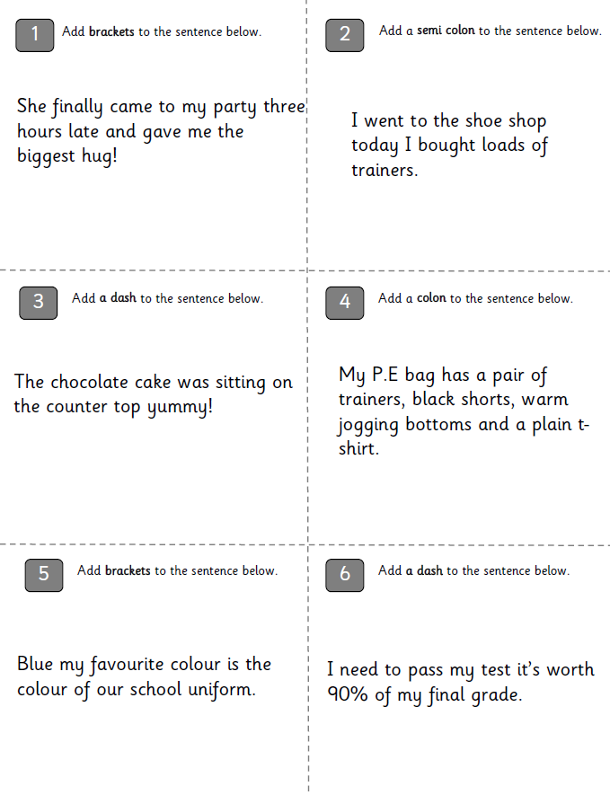
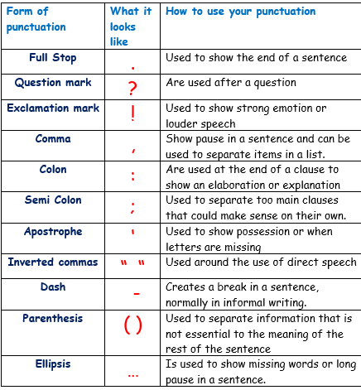

Year 5
Reading Activity – Week 6
LO: We are learning to retrieve information and make inferences from a text.
For your reading activity this week, can you focus on retrieving information and making inferences from the first page of the book below? The extract is from ‘Fire-Girl’ by Matt Ralphs.
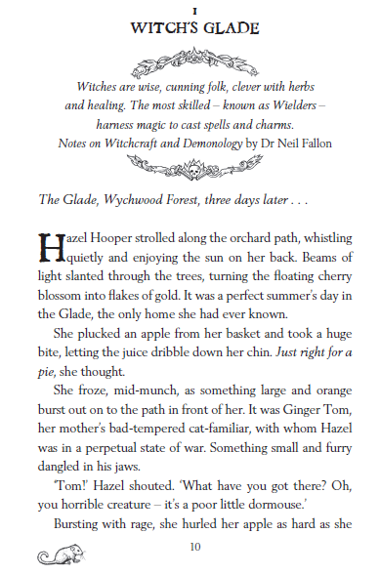
Retrieving Information
- Find and copy a phrase that shows it is warm in the forest.

- What are the most talented type of witches called?

Making Inferences
- Use evidence from the text to explain how Hazel feels when she sees Ginger Tom.

- Does Hazel find magic easy? Give two reasons for your answer.

- What might be causing the “foul smell”?

Challenge Question (extended answer)
- What do we know about Hazel and her life? Use quotes from the text to back up your answer.

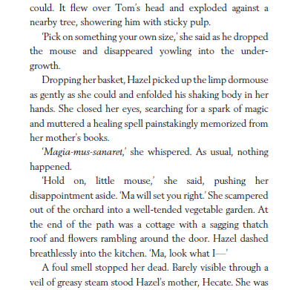

Year 5
Writing Activity – Week 6
Learning Objective:
We are learning to write, using organisational and presentational devices appropriate for our form of writing.

For you writing this week, your task is to use something that has happened since you have been at home as inspiration. You can choose to write about something new you have learnt, a new hobby, what you have been up to in general or your learning from home. You can choose how you present this, it could be:

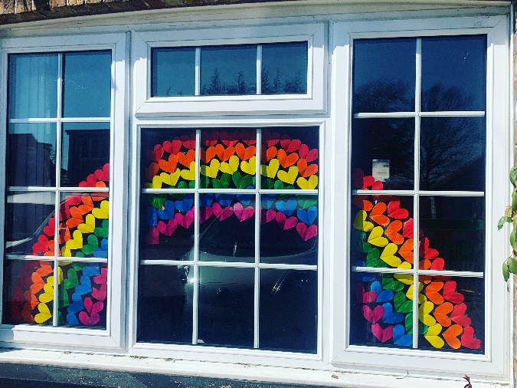
- A fact file
- A script or story about something that happened on a really good day
- A diary entry
- A newspaper report
- A poem
- Instructions (for a new hobby/ something new you have learnt)

For example, you might choose to write instructions for how to bake delicious cookies, write a diary entry from a hot day spent at the park. You could write a newspaper report about something exciting (for example a breaking news story from when you cleaned your room or went on one of your walks or bike rides), a fact file with information about things to do when you are staying at home! You could even write a poem about your favourite place that you have been to since being at home - there was a beautiful poem written about the lakes at Sheepwalk a few weeks ago!

Use the next few pages to guide you with your writing; we are really looking forward to seeing your creativity!

Diary entry:
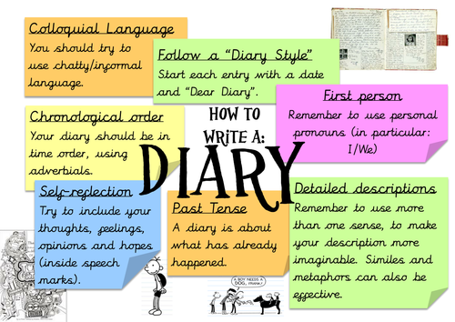

Poetry:
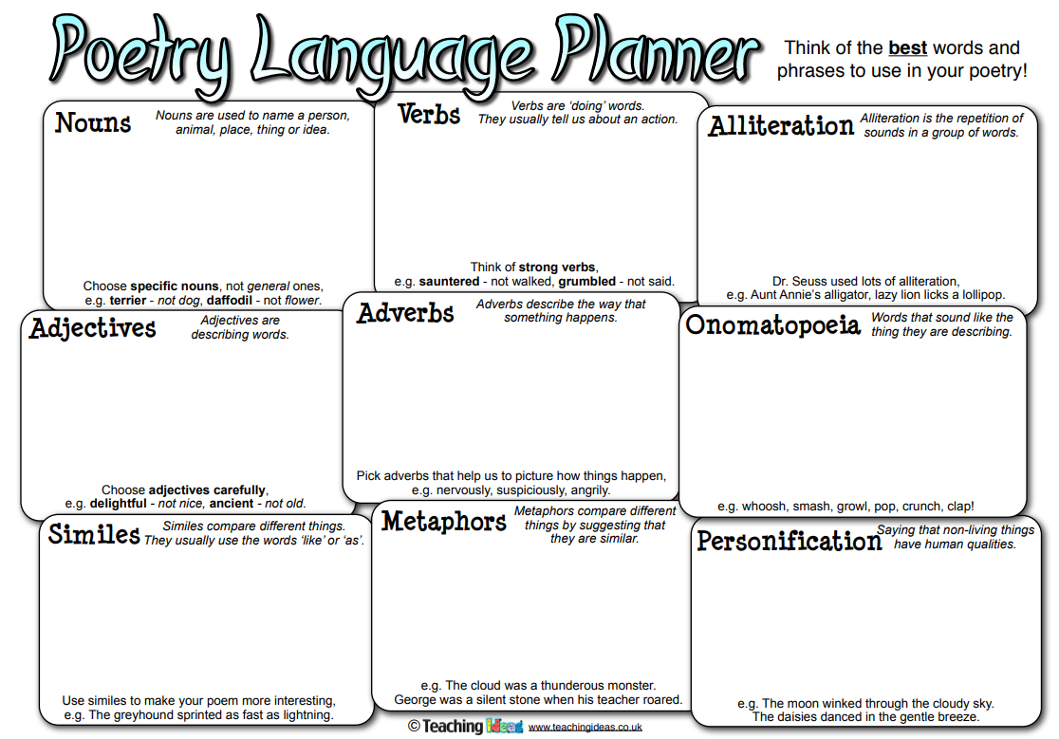

Newspaper report: Instructions:
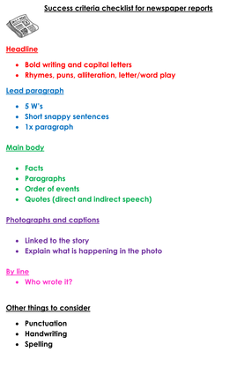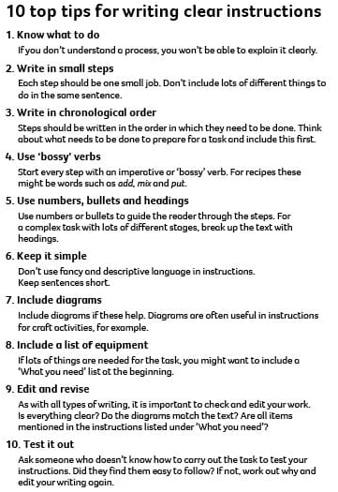

Non-chronological report (fact file) –


