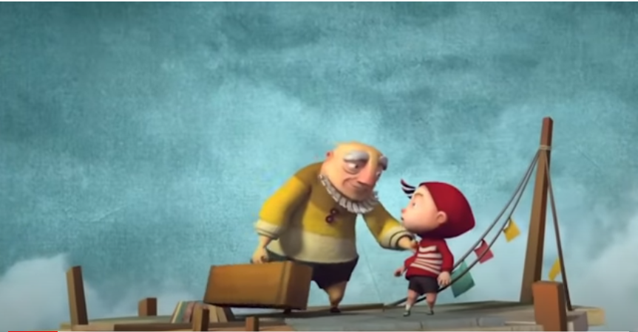
Home Learning Writing Guidance
A cloudy lesson
Singular Possessive Apostrophe
This is used if there is only one person or thing and something belongs to that person or object.
Eg The boy’s wispy hair fluttered in the wind. John’s ruby hat fitted snuggly on his head. The elderly man’s pointed nose was red from the cold wind. The washing line’s rope had become slack.
Who are the characters? Friends or grandfather and grandson?
Diary entry guidance
Was this your first attempt at blowing clouds? Who is the man and why is he training you? How were you feeling before your training? What was it like trying to blow your first cloud? What did the man’s wand look like? What did the man look like? What were the features on his face like? What did the man say to you when you bent the wand? Were you expecting what happened next? How will you remember this day? What was in the man’s suitcase?
Helpful vocabulary
bearded, skilled, compassionate, patient, caring, able, thoughtful, kind, expert, encouraging, expression, engrossed, disheartened, inability, tackle, ruby, scarlet,
The man’s patient face. The wand’s warped shape created intriguing clouds.

