Activity 1: Puzzles

Have a go at these puzzles and then try to explain your reasoning and thinking in a paragraph.
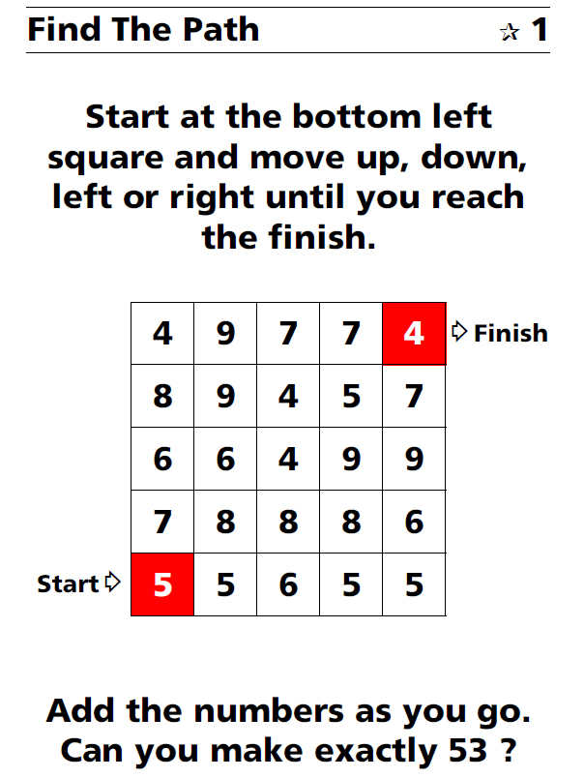

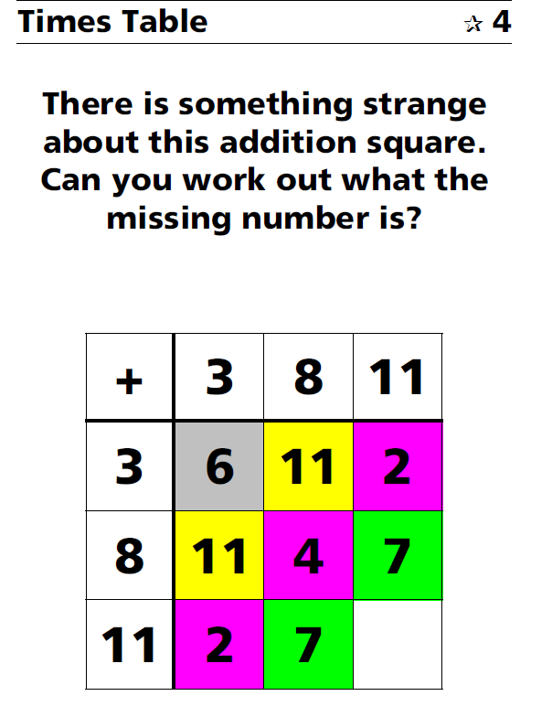

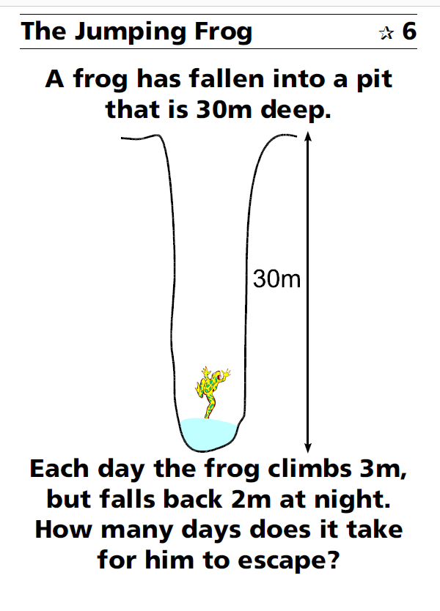
Activity 2: Ring a Ring of Numbers

Here is a picture of four numbers placed in squares on a circle so that each number is joined to two others:
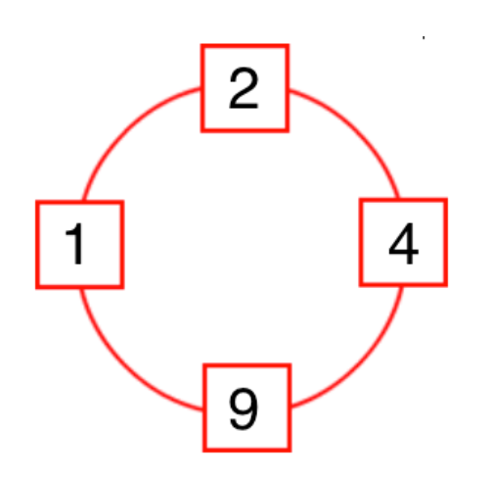
- What do you see?
- What do you notice?

Task
- You can use the templates on the next page to record your working out

- Choose four numbers from this list: 1, 2, 3, 4, 5, 6, 7, 8, 9 to put in the squares so that the difference between joined squares is odd.

- Only one number is allowed in each square. You must use four different numbers.

- What can you say about the sum of each pair of joined squares?

- What must you do to make the difference even?

- What do you notice about the sum of the pairs now?

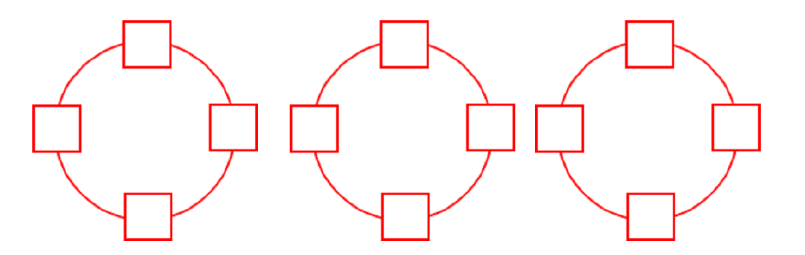

Activity 3: Reach 100

Here is a grid of four "boxes:
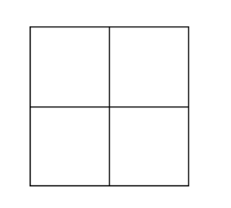

You must choose four different digits from 1−9 and put one in each box.

For example:
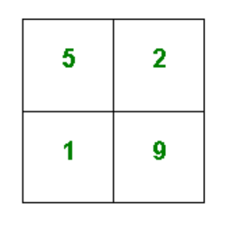
This gives four two-digit numbers:
52 | (reading along the 1st row)
19 | (reading along the 2nd row)
51 | (reading down the left hand column)
29 | (reading down the right hand column)
In this case their sum is 151.

Try a few examples of your own.
Is there a quick way to tell if the total is going to be even or odd?
Your challenge is to find four different digits that give four two-digit numbers which add to a total of 100.

How many ways can you find of doing it?

Activity 4: Ice Cream Investigation


The ice cream stall sells chocolate, peach, mint, lemon, strawberry and vanilla flavour.

What combinations can be created for a double cone?

Be sure to work systematically and record your solutions in an order.

How will you know once you have found all the possibilities?

Activity 5: Sticks Investigation

See if you can work out the number of intersections for up to at least 10 sticks.

