Science Investigations

When you carry out science investigations you are working scientifically and this involves lots of different skills, which you will use and develop this week.

Investigations
Option A
- Go to this website: https://www.rigb.org/families/experimental
- Look through the list of different experiments
- Choose one you are interested in
- Watch the video
- Download the instruction sheet
- Have a go at the experiment!
- Write up your experiment using the framework in this document

Option B
- Look through the activities in this document
- Choose one you are interested in
- Carefully read though all the information
- Have a go at the experiment!
- Write up your experiment using the framework in this document

Working Scientifically

- I can take accurate and precise measurements using a range of equipment

- I can record data and results using tables and graphs

- I can use test results to make predictions

- I can report on my findings and make conclusions

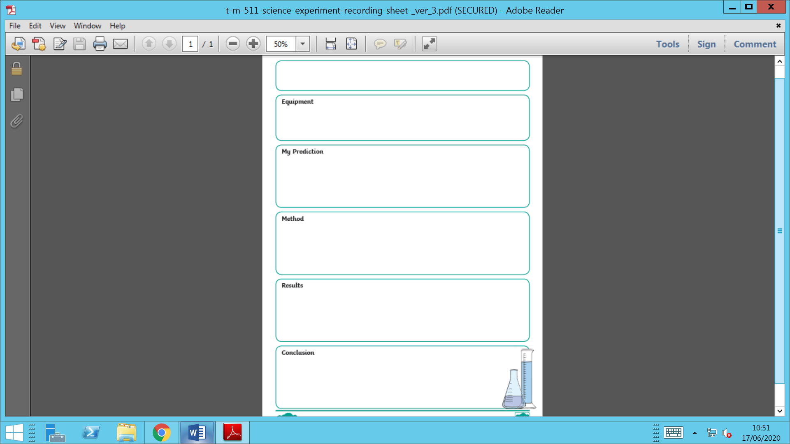
Investigation

