- She picked the pencil up and began to ____________.
Words which contain silent letters

Use these words to complete the sentences below…
Write, autumn, column, knight, knuckles, knot, school, hour, campaign
Have a dictionary or access to the internet nearby so that you can check the meaning of the words to fit them into the sentences below!
Year 5 – Week 4 - Spellings
- Grant started a ____________ to support the environment.
- Each day you learn something new at ____________.
- Harry tied a ____________ to secure the sail on his boat.
- It will take over an ____________ to get there!
- In ____________ many leaves change colour and fall off of the trees.
- The ____________ rode his horse into battle.
- You can use your ____________ as a trick to see how many days are in each month.
Write a paragraph using as many silent letter words as you can! Try and make it as silly as possible!

#

Spelling, Grammar and Punctuation Challenge Tasks:
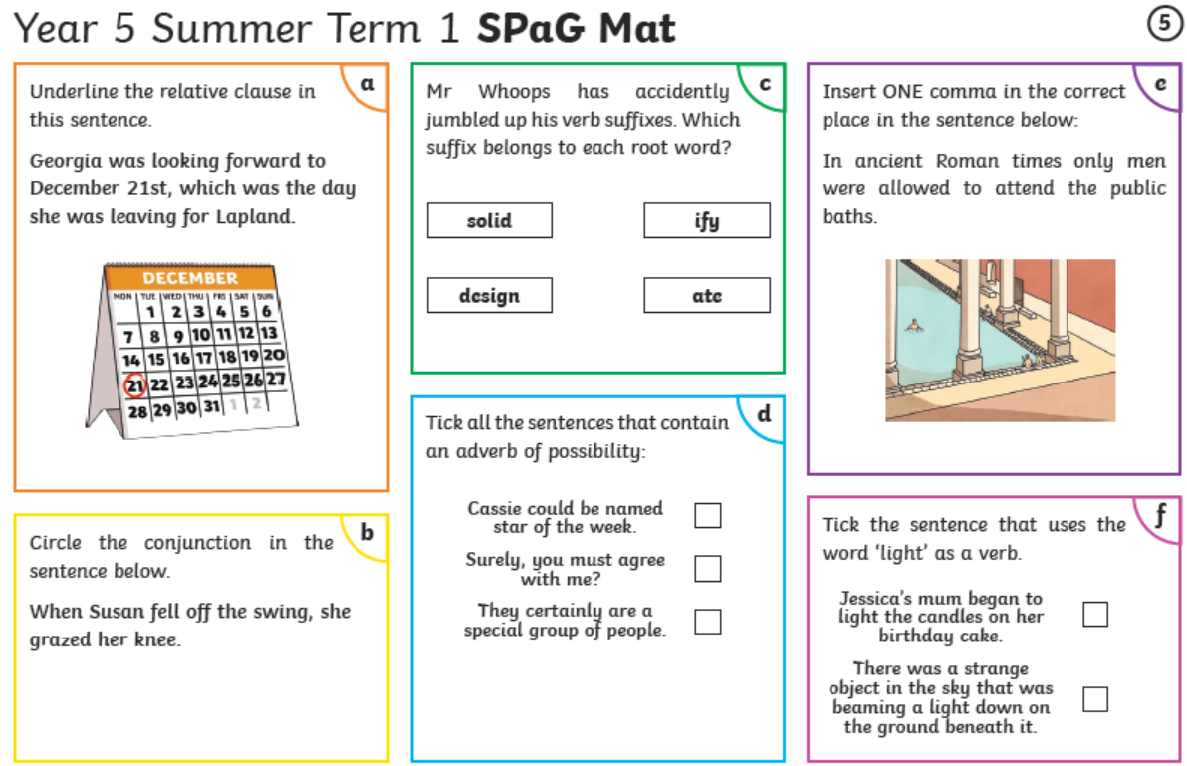
Year 5
Reading Activity – Week 4
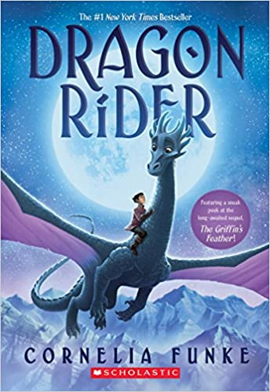
LO: We are learning to discuss and evaluate how authors use language.
Read the extract from ‘Dragon Rider’ on the next page and answer the questions below.

- Can you read the text aloud on your own or with an adult?

- If there are any words that you are unsure of, use a dictionary or the internet to find their definitions and write them below.

- Read the first paragraph again. Can you pick out 3 words or phrases that help to set the atmosphere?

- What simile has been used to describe the boy? What do you think this tells us about his character?

- Can you find an example of personification in the text? What image does it bring to mind?

- What do you think happens in the story?

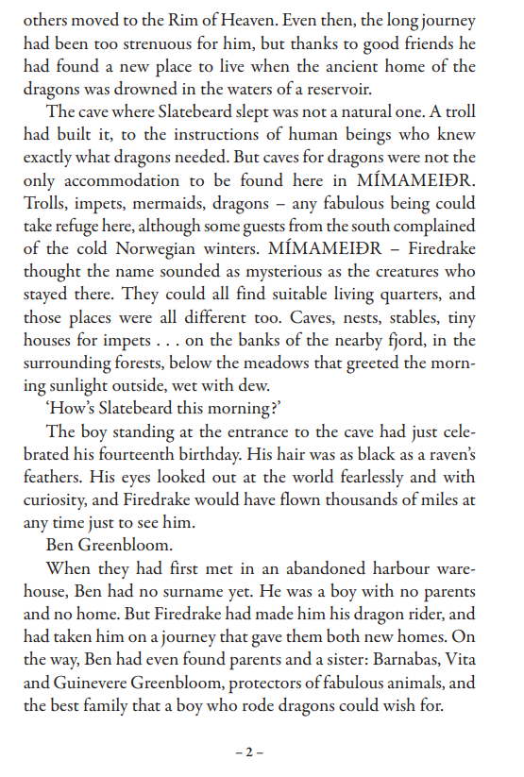
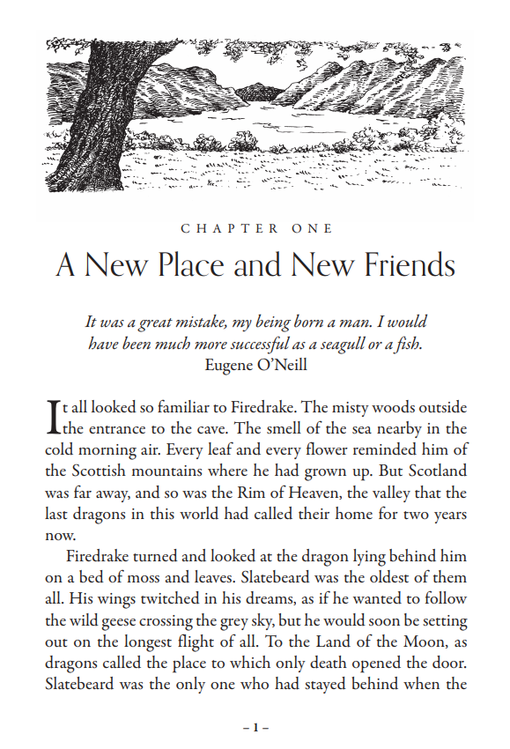

Year 5
Writing Activity – Week 4
Learning Objective:
We are learning to write using further organisational and presentational devices to structure text and to guide the reader (headings, bullet points, underlining etc.)

What would your dream job be when you are older? Or what job do you think would be great to do?

Can you create a job advert for this job? Think about:
- Outline the job and key responsibilities
- What skills are required
- What type personality does the person need
- What qualifications they need

Plan your job advert using the planning sheet on the next page and then present it as an advertisement to go in the local paper! Remember, add persuasive language, use organisational devices to make your advert easy to read and add pictures.

Examples of dream jobs:

- Video game tester
- Animal carer
- Sailor
- Hairdresser
- Coder
- Detective
- Footballer
- Racing driver


