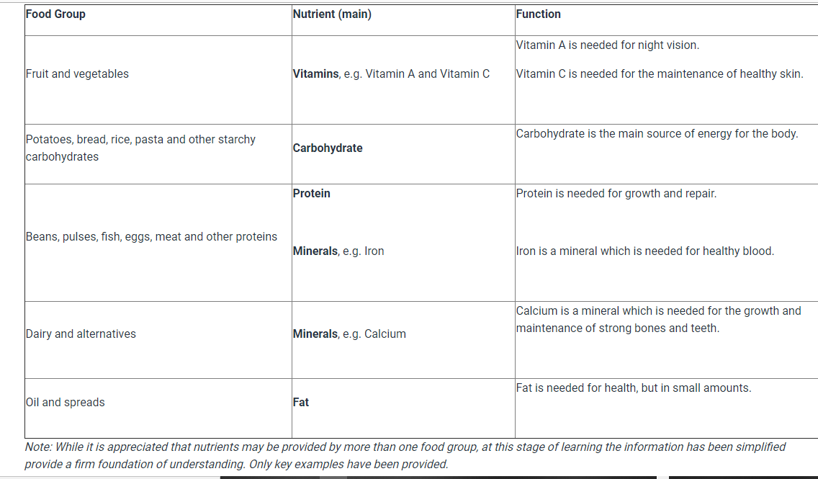
Guidance for parents. This will provide an illustration to the level of understanding and knowledge expected on this subject in Year 3.

