Year 3 Maths Guidance
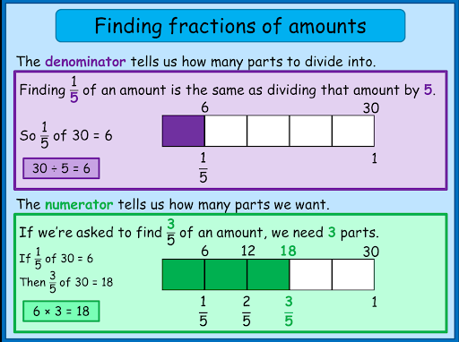
Bar model to solve fractions of amounts
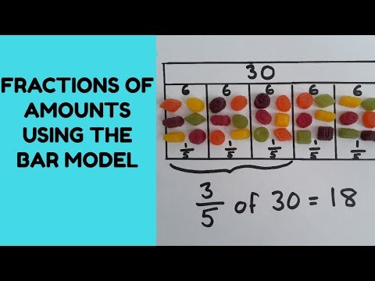

Number facts to help solve questions
Remember
If I know ½ of 8 = 4 then I know 1/2 of 80 = 40

Stem sentences:
‘A fraction is any part of a whole group, number or whole’

$\frac{1}{5}$ ‘The whole is divided into 5 equal parts. Each part is one fifth of the whole. I have 1 equal part.’

‘The denominator (bottom number - down) tells us how many parts the whole is divided into’
‘The numerator (top number) tells us how many parts we have or are looking at’
Miss Brown’s Favourite maths fact: The line part of the fraction is called the vinculum
(or you can just call it the fraction bar).

