Guidance
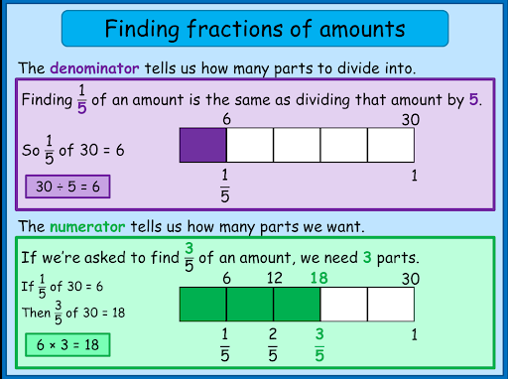
Bar model to solve fractions of amounts
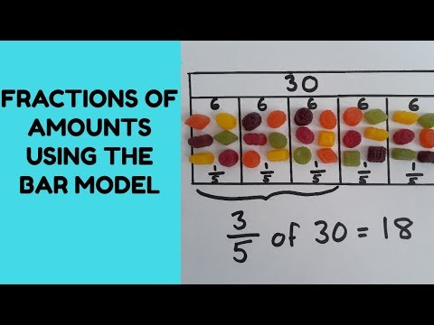

Number facts to help solve questions
Remember
If I know ½ of 8 = 4 then I know 1/2 of 80 = 40

Stem sentences:
‘A fraction is any part of a whole group, number or whole’

$\frac{1}{5}$ ‘The whole is divided into 5 equal parts. Each part is one fifth of the whole. I have 1 equal part.’

‘The denominator (bottom number - down) tells us how many parts the whole is divided into’
‘The numerator (top number) tells us how many parts we have or are looking at’
Miss Brown’s Favourite maths fact: The line part of the fraction is called the vinculum
(or you can just call it the fraction bar).
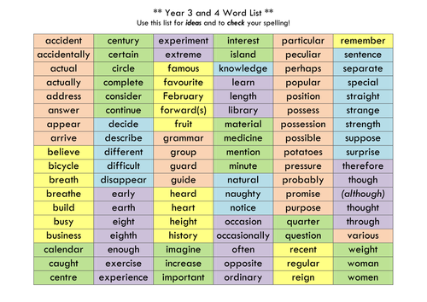
Writing Guidance
Can you apply any of these spellings correctly or from the home learning list?
How to use headings and subheadings.
You could write your subheadings first to help you plan and then write notes or key word under each heading before you write it up. Subheadings do not need to be a question but sometimes this is relevant.
Write a newspaper report, or website page
You could use a favoured footballer, or an inspiring sports person such as Michael Jordan who used his growth mind set and overcame difficulties to achieve. You may choose a family member who has not been athletic but has started exercising more regularly. You could interview them and then group the answers together under a subheading. What was their motivation? What did they enjoy the most and the least about their activity? How did they make sure that they completed it? What did they wear and where did they go for it? What was their diet? You could also write it as if they are famous!
Story
What did the character want to do? For example, climb a mountain or row a boat across oceans? What problem did they encounter? How did they get over it?
Paragraph 1 Describe the setting and main character.
Paragraph 2 Explain the activity.
Paragraph 3 Describe what has gone wrong.
Paragraph 4 How was it over come and the ending.

