Writing Guidance
Senses for description
It tastes…   | It feels …  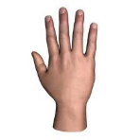 | It looks…   | It smells…  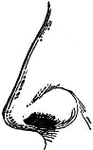 | It sounds… 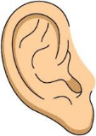
sweet | prickly | dark | fresh | loud
sour | smooth | shiny | delicious | noisy
bitter | rough | long | bitter | quiet
crunchy | soft | skinny | rotten | silent
salty | hard | fat | salty | squeaky
chewy | silky | thin | smoky | creaky
dry | thick | small | sour | melodic
juicy | sticky | large | spicy | fizzy
hot | heavy | speckled | stale | shrill
fizzy | light | light | stinky | deafening
tasteless | bumpy | bright | sweet | faint
delicious | spiky | dotted | smelly

Maths Guidance
https://static.mymaths.co.uk/xml/player/v2.2.9/build/index.html?contentPath=../../../en/primary/number/fractions/primary_nc_year3_fractions_on_the_number_line_lesson
Click on this link and you should see this page:
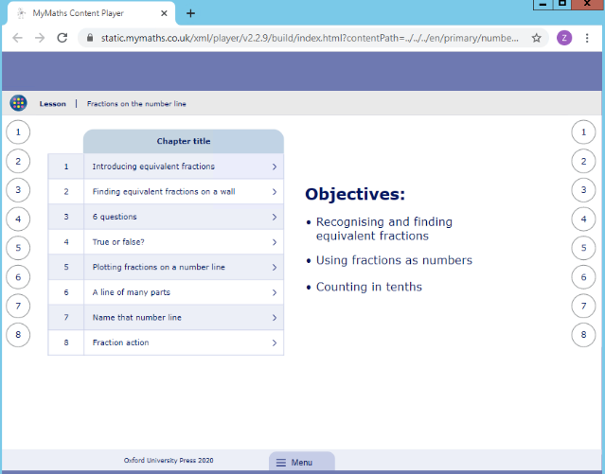
Click on the chapter title 1 ‘introducing equivalent fractions’
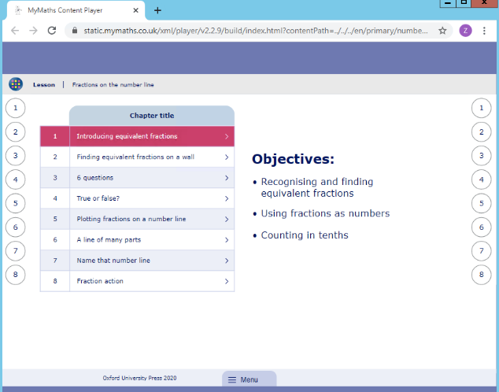
You should then see this page. Use the next button to move through the lesson.
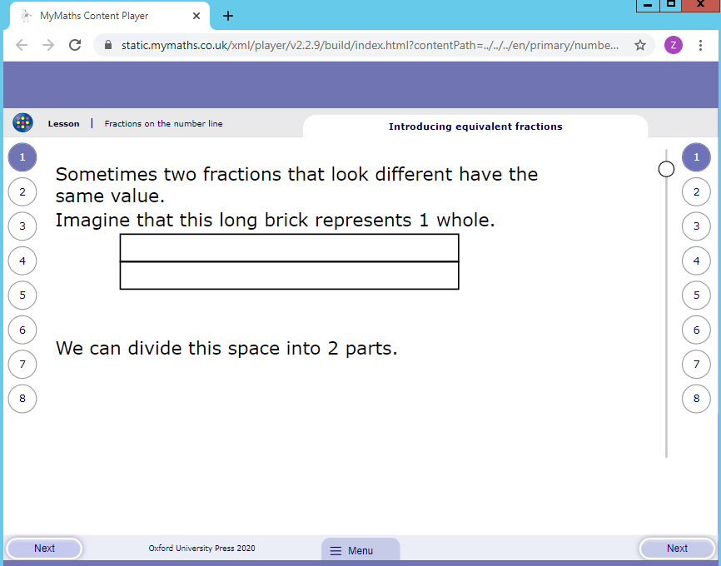
When you reach the end of the first session click on the number 2 along the right hand side of the page. Then use the next button to work through this part of the lesson.
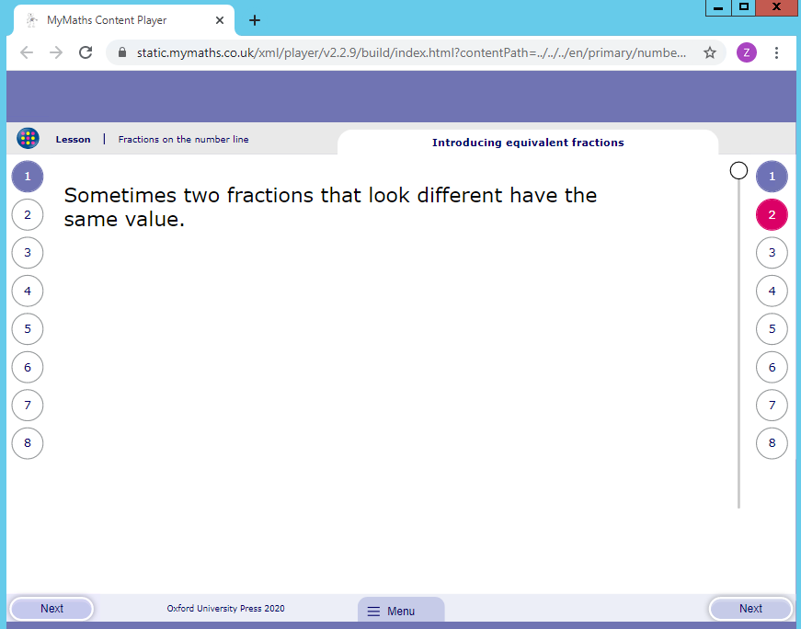

Poster example:
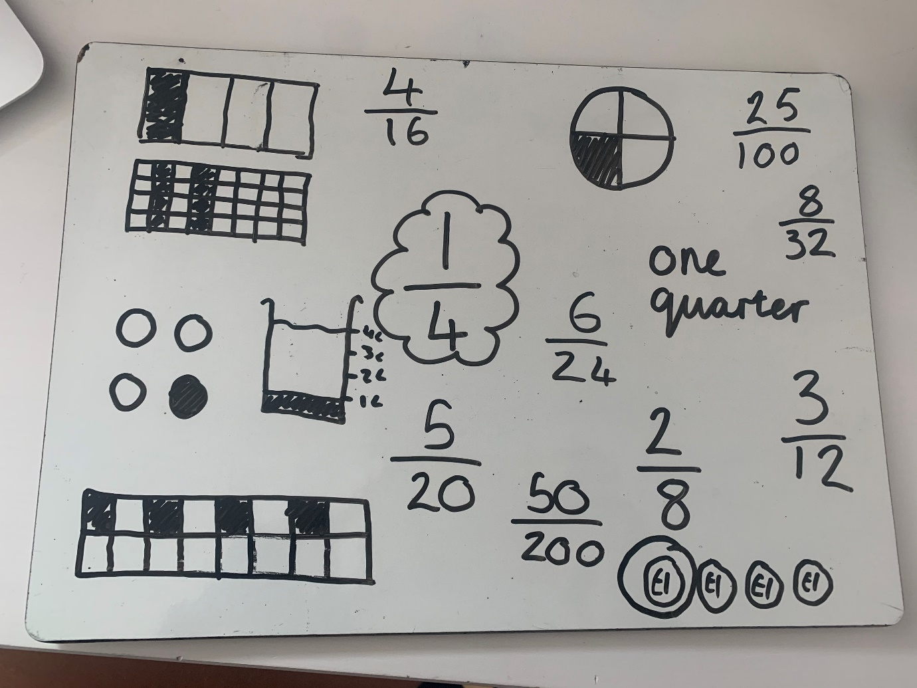

Stem sentences:
‘A fraction is any part of a whole group, number or whole’

$\frac{1}{5}$ ‘The whole is divided into 5 equal parts. Each part is one fifth of the whole. I have 1 equal part.’

‘The denominator (bottom number) tells us how many parts the whole is divided into’

‘The numerator (top number) tells us how many parts we have or are looking at’

Miss Brown’s Favourite maths fact: The line part of the fraction is called the vinculum
(or you can just call it the fraction bar)

