Bread Week
This week in school would have been Bread Week for year 5, so the learning from home will be all about bread!

There are lots of different activities for you to choose from which allow you to develop your understanding of how bread is made, the science behind it and different types of bread around the world.

We would love to see your learning from this week, so don’t forget to send us in some photos to: learning.saxon@lumenlearningtrust.co.uk

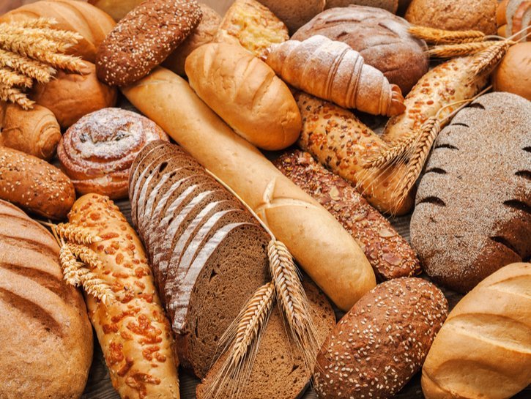



Activities

Science – Experiment

Task: Yeast is needed to bake bread; have a go at the science experiment on the next page involving yeast.

Once you have completed the experiment, see if you can write it up. Remember to include the follow: aim, prediction, equipment, method, results and conclusion.

DT – Cooking

Task: Have a go at baking some bread!

There are so many different types of bread you can make, so first of all spend some time having a look at different recipes and videos on youtube. You could even have a go at designing your own bread using the worksheet on the next page.

Once you have baked your bread, send us in a photo and tell us how it went!

Geography – Bread Around the World

Task: Find out about different breads around the world. Can you make a world map of breads?

You could also use the sheet on the next page to find out more about particular types of bread.

Science - Experiment
Bread
Week

DT – Designing Bread

DT – Making Bread

DT – Making Bread

Geography – Bread Around the World

