- The sheep had a new born baby ____________ at its side.
Words which contain a silent letter b

Use these words to complete the sentences below…
Climb, comb, crumb, doubt, lamb, numb, subtle, thumb
Have a dictionary or access to the internet nearby so that you can check the meaning of the words to fit them into the sentences below!
Year 5 – Week 2 - Spellings
- I am not sure if I can ____________ up to reach it!
- The cake was do delicious, I did not leave a ____________.
- The detective had no ____________ that the woman was guilty.
- It was so cold that Shackleton’s hands went _____________.
- She used her ____________ to brush through her hair.
- Steve shut the door and trapped his ____________.
- George had to be ____________ when he approached the rabbit, to ensure that he did not scare it!
Write a paragraph using as many silent b words as you can! Try and make it as silly as possible!

Spelling, Grammar and Punctuation Challenge Tasks:
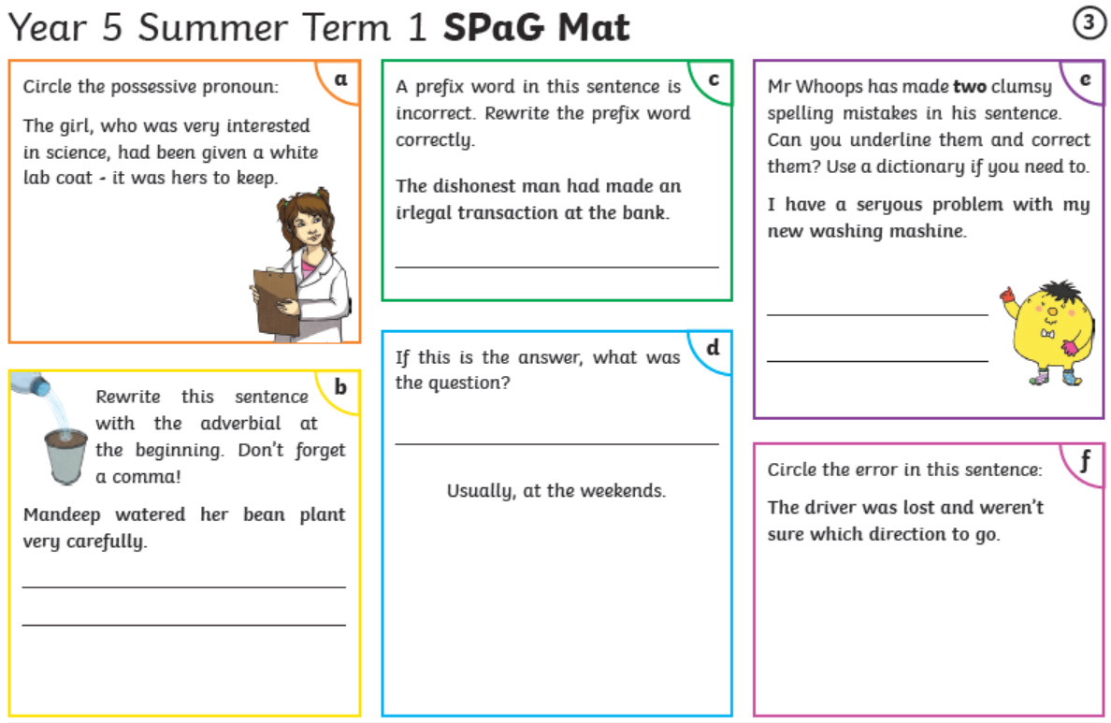
Year 5
Reading Activity – Week 2
LO: We are learning to predict what might happen from details stated or implied.
Please complete the question below, then use the book you are reading to complete the prediction sheet on the next page!
Can you read the paragraph below and predict what will happen next?
It was the middle of winter and all week the children had been hoping and praying that snow would fall. They wanted to have snowball fights on the field and make snowmen. Every day they would go to school, their teacher would be talking and the children would be staring out of the window, looking at the clouds in the sky. One morning, they woke up and it was colder than it had been all week. They looked out of their bedroom windows and wide smiles stretched across their faces.

What do you predict will happen next?

What clues did you use to make your prediction?

Predicting isn’t just about guessing, it is about being a detective, using the author’s clues in the story to help you think about what might happen next!

I predict that ….
I think …. will happen because…
The author wrote… which made me think…
When I read… it made me realise…
I can tell… is … because…
How the character acts tells me…
What the character… this shows me…

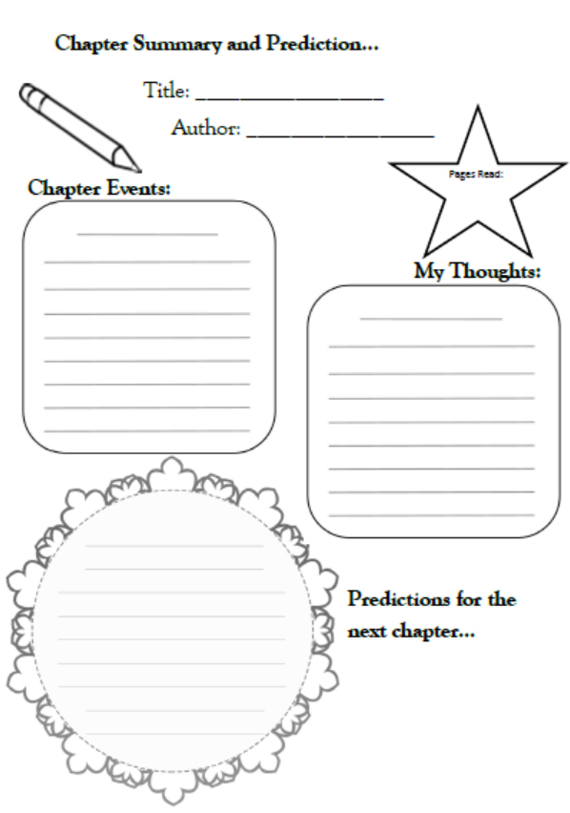

Year 5
Writing Activity – Week 2
Learning Objective:
We are learning to evaluate and edit by assessing the effectiveness of our own writing.

This week, your writing task is to create an advertisement for a useless object (thank you Suheli for the suggestion!). Make sure to include:
The name of the product | A statement saying what the item is and what it is used for, give a lot of detail! | Use alliteration, rhyming words and word play to make it memorable and fun.
Exaggerate all the positive points of your product using words like ‘best’, ‘cheapest’ and ‘most’. | Ask the reader questions that will make them think they would need the product to change their life e.g. ‘Have you ever needed relief from the scorching sun’. | Explain WHY the reader should buy the product.

The aim of your advertisement is to encourage someone to buy the product!
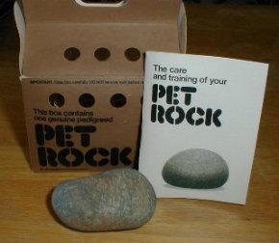
Some ideas for your advertisement:
- Selling a pet rock
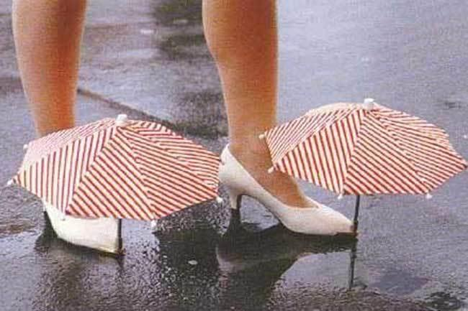
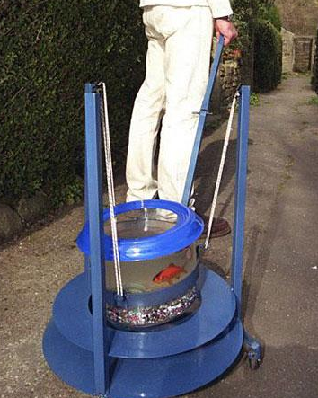
- Selling shoe umbrellas

- Selling a goldfish walker

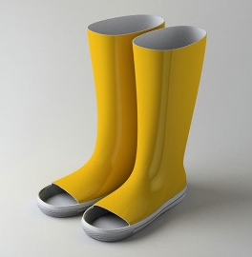
- Selling toeless wellies

- Another useless object you can think of!

You can present your advertisement in different ways:
- Speech – write and record a radio advert
- Writing – write an advertisement to go on a magazine or newspaper
- Poster – create a poster advertisement to go on display in a shop
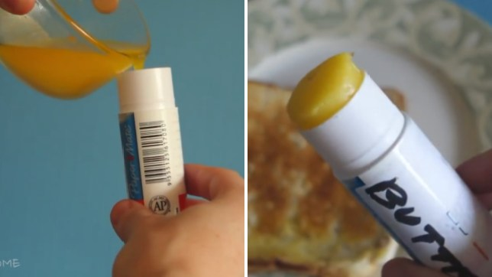
Example advert:

This is how we should all be spreading our butter

Have you been betrayed time and time again by your overly hard, non-spreadable, so-called ‘spreadable’ butter? Felt the pain as you tear holes in your bread desperately trying to spread that ever-so-salty Lurpak? Or maybe you have been taunted by the image of a hot cross bun oozing melting butter that you so desperately try to re-create, but fail miserably as the butter refuses to be anything to your bun but a hard greasy lump.

Now we have found the way out of all your butter woes with an incredibly wonderful creation. Ladies and gentlemen, please put your hands together for the Ultimate Butter Spreader.

The best product to fulfil all of your butter spreading needs, our Ultimate Butter Spreader provides the ultimate experience. The cheapest product on the market, it will revolutionise the way you spread your morning toast and change your life. At only £9.99 it is an absolute steal, buy today before you miss out tomorrow.

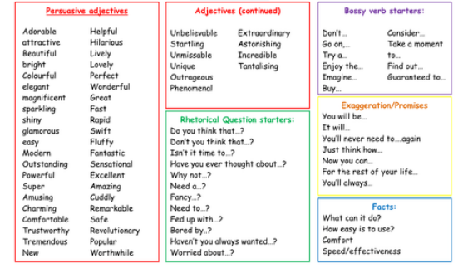

Make sure your advertisement is effective, read through and edit to ensure you have used the best language choices possible!
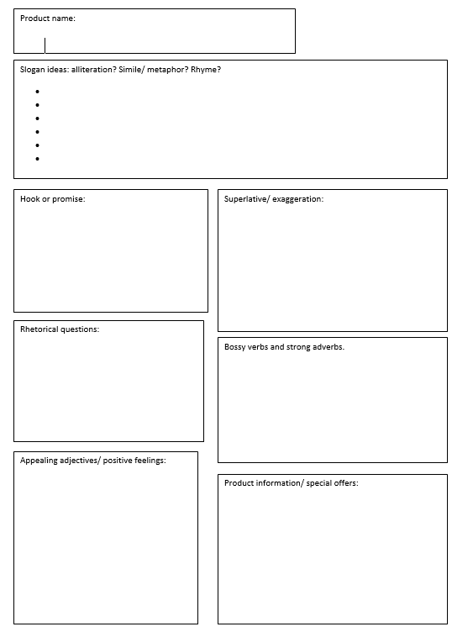
Advertisement planning sheet:

