Writing Guidance
This is an example of a piece of writing from the perspective of a female lion.

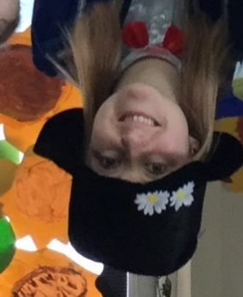
Miss Browns WAGOLL (What a good one looks like)
I am hungry, no I am starving, every part of my body longs for food. My tummy is rumbling like a volcano about to erupt. My mouth is salivating like a dog waiting for dinner. My brain cannot focus on anything else. I need food. It has been a long day with my pride, the other female lions and I have been on the hunt for food all morning and yet we have found nothing. A few of the others have started to squabble and fuss but not me, I know I must keep laser sharp focus if I want to bring home dinner today.
I hear a noise, my ears twitch and my shoulders begin to arch. I can see dinner……………………………….

Maths Guidance
Click on the link below:
https://whiterosemaths.com/homelearning/year-3/
You should then see this:
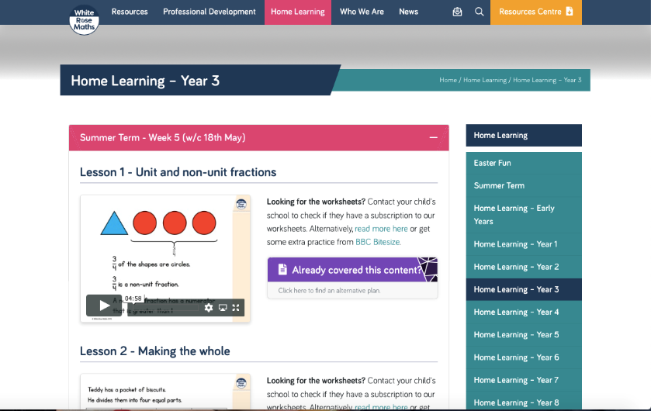
If you press the – in the pink bar your screen should then look like this:
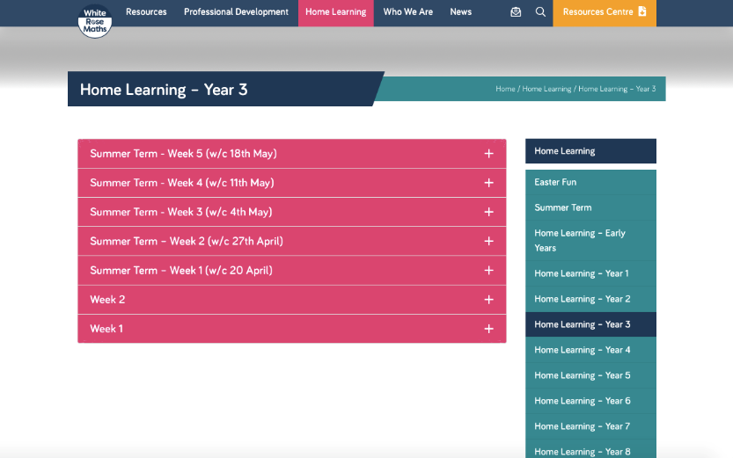
Click on the pink tab which says ‘Summer Term – Week 3 (w/c/ 4th May)
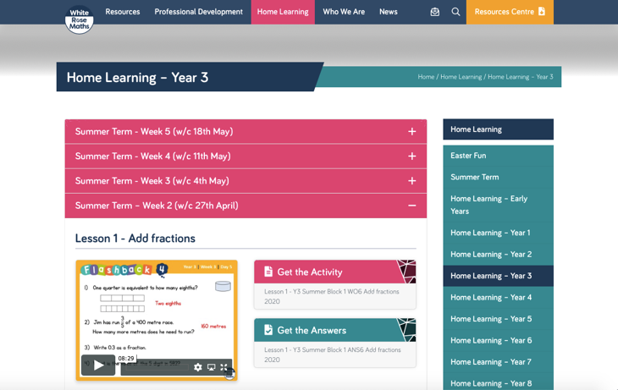

Stem sentences:
‘A fraction is any part of a group, number or whole’

$\frac{1}{5}$ ‘The whole is divided into 5 equal parts. Each part is one fifth of the whole. I have 1 equal part.’

‘The denominator (bottom number) tells us how many parts the whole is divided into’

‘The numerator (top number) tells us how many parts we have or are looking at’

Miss Brown’s Favourite maths fact: The line part of the fraction is called the vinculum
(or you can just call it the fraction bar)

